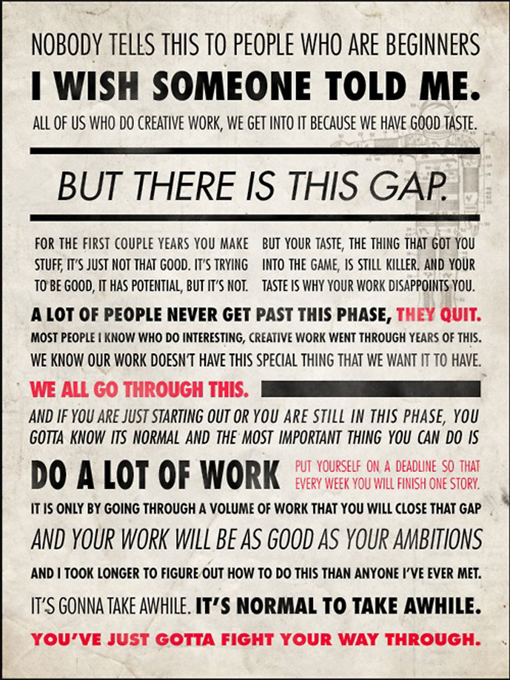
- Ira Glass

TABLE OF CONTENTS

4 Welcome
5 Overview
6 Academic Program Fact Sheets
14 Fine Art Assessment Plan
15 Graphic Design Assessment Plan
17 Fine Art and Design Faculty
19 Scholarship Opportunities
23 ECC Art Gallery Schedule
24 Studio Guidelines
29 Art Vocabulary
32 Academic Calendar
34 Course Descriptions
43 Supplemental Information From the ECC Student Handbook (Policies and Procedures)

The purpose of the ECC Fine Art and Design Student Handbook is to provide information on the programs of Fine Art and Design at East Central College. It contains information to assist you on your creative journey. It also includes information and resources concerned with administration, policy and regulations taken from the ECC Student Handbook. This Fine Art and Design Student Handbook is not a substitute for the entire contents contained within the official East Central College Student Handbook.

Dear ECC Fine Art and Design Student,

Whether you are new to ECC or returning to campus we welcome you to the East Central College Department of Fine Art and Design! You are stepping into a thriving culture of Fine Art and Design that will challenge and inspire you. We take great pride not only in the quality of our programs and our faculty and staff but also our ability and dedication in providing you with an outstanding education. There are four different degree pathways inside the Department of Fine Art and Design: the Associate of Fine Arts degree, the Associate of Arts in Studio Art, the Associate of Applied Science in Graphic Design and the Associate of Applied Science in Multi Media. So whether you are interested in becoming a practicing artist, an art historian, an art educator, graphic designer, illustrator or animator we have your foundation covered.

Here at ECC you will find our faculty are practicing artist educators offering instruction in all of our studios. We have up to date and industry standard technology throughout our studios. In our Art Gallery we exhibit work by students through Internationally recognized artists throughout the academic year. Our students have the opportunity to learn valuable skills and networking by working in the gallery. Students are encouraged to participate in the ECC Art Club, which endeavors to bring Art inspired projects to campus, as well as, fundraising to make a yearly pilgrimage to London, UK. The Department of Fine Art and Design also has many generous scholarship opportunities for students studying Art and Design.

In the Department of Fine Art and Design we create a culture of creativity and one that encourages experimentation and exploration. We foster an atmosphere that breeds artistic excellence in our community. After graduating, our students have proven to be successful in their future studies and in their careers in art and design.

It is our pleasure and our goal to provide every student with the very best experience, advice, atmosphere and creative input to succeed in the Department of Fine Art and Design at East Central College. This will only be enhanced as East Central College is in the process of becoming an accredited institutional member of the National Association of Schools of Art and Design.

We believe in all of you and are excited to embark with you on this journey. Please feel free to contact any one of us for assistance or more information.

Best Regards,

Adam Watkins Jennifer Higerd Sean Barton
Instructor of Fine Art Instructor of Fine Art Instructor of Graphic Design
Artist Mentor Gallery Coordinator and Multi Media

East Central College Mission Statement
East Central College will provide an environment for lifelong learning.

Vision Statement
East Central College will connect its community to its future.

Art Department Mission
The East Central College Art Department's mission is to provide a strong foundation rooted in the principles of art and design and foster a creative atmosphere fundamental to life long learning in which a student develops mastery of skills and techniques, develops critical and creative approaches to problem solving that are communicated in a visual context as well as in written and verbal format, becomes socially aware of trends and traditions of the larger art world both past and present in preparation for transfer.

Art Department Goals
Graduates of this program should be able to demonstrate the following art specific tasks, as well as implement ECC’s Common Learning Objectives:

• Be ethical and socially responsible
• Be able to communicate effectively in a written and verbal manner
• Be able to think critically and creatively to solve problems and advance solutions
• Demonstrate proficiency in the basic artistic materials, techniques and principles of art and design
• Understand major art works from the past, the styles they represent, and their significance for artists today
• Discuss and analyze major issues facing the art world today
• Select and prepare artworks for exhibition
• Document their artwork
• Prepare a comprehensive portfolio that demonstrates competence in all areas of art foundations

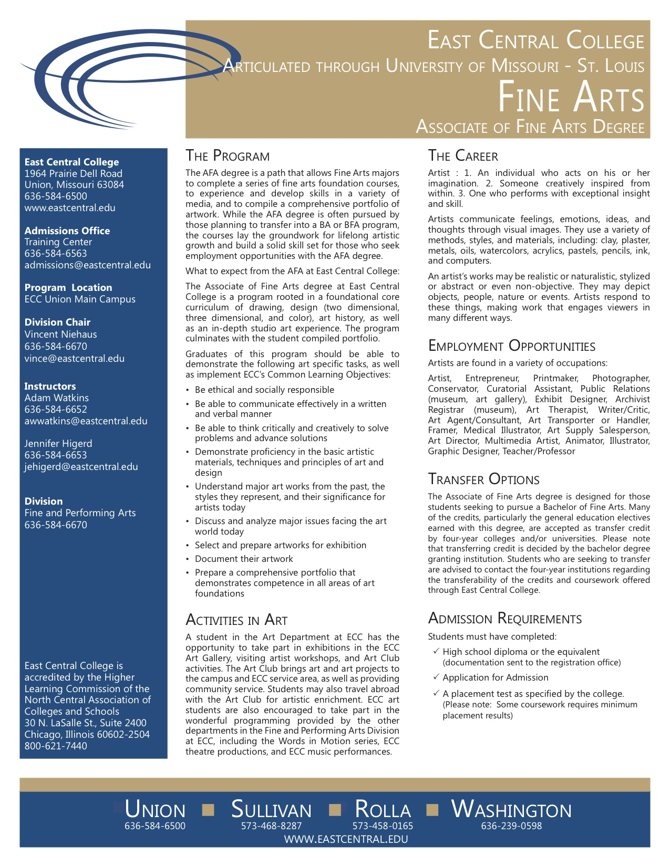

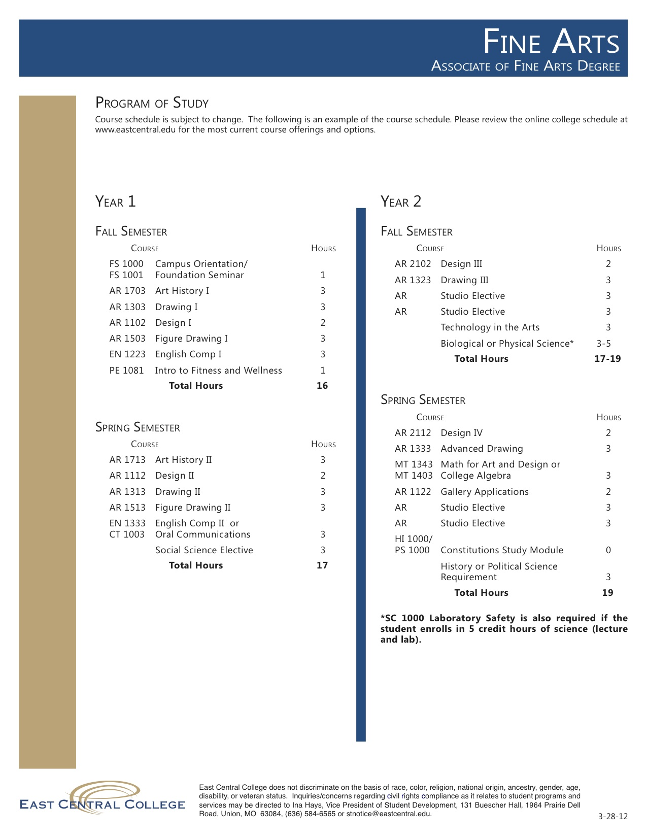

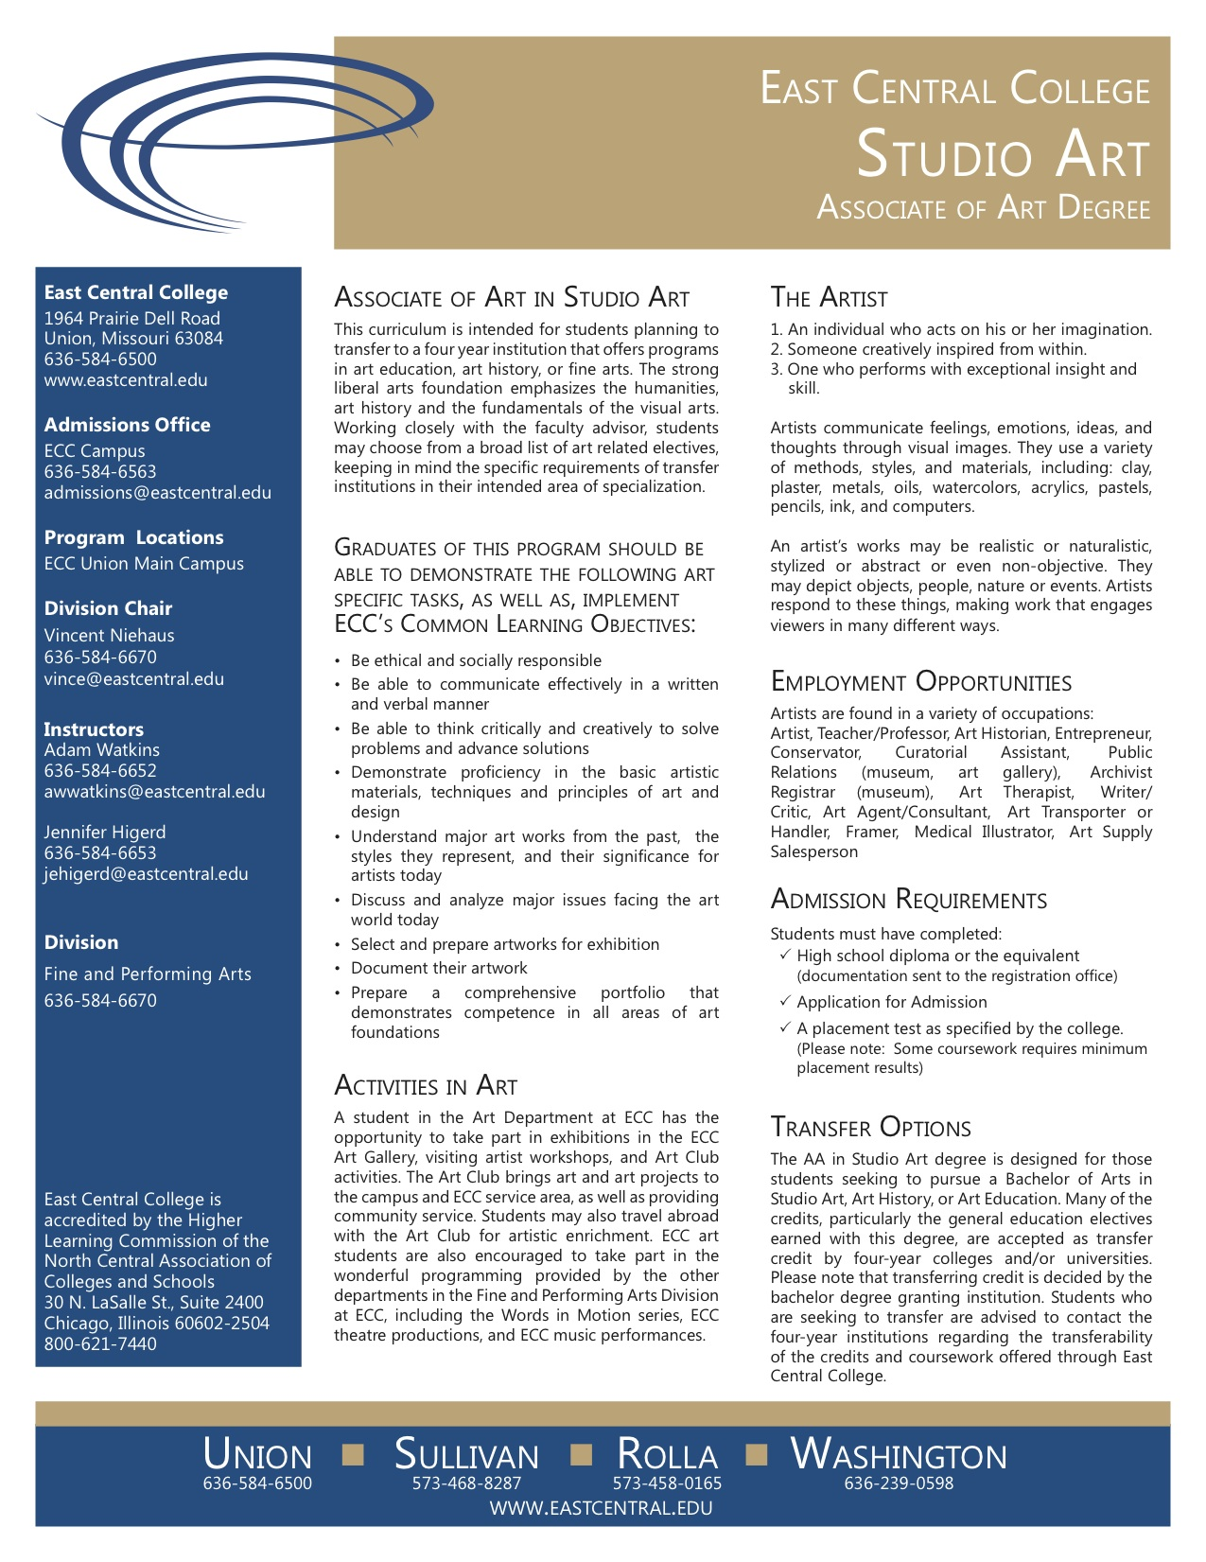

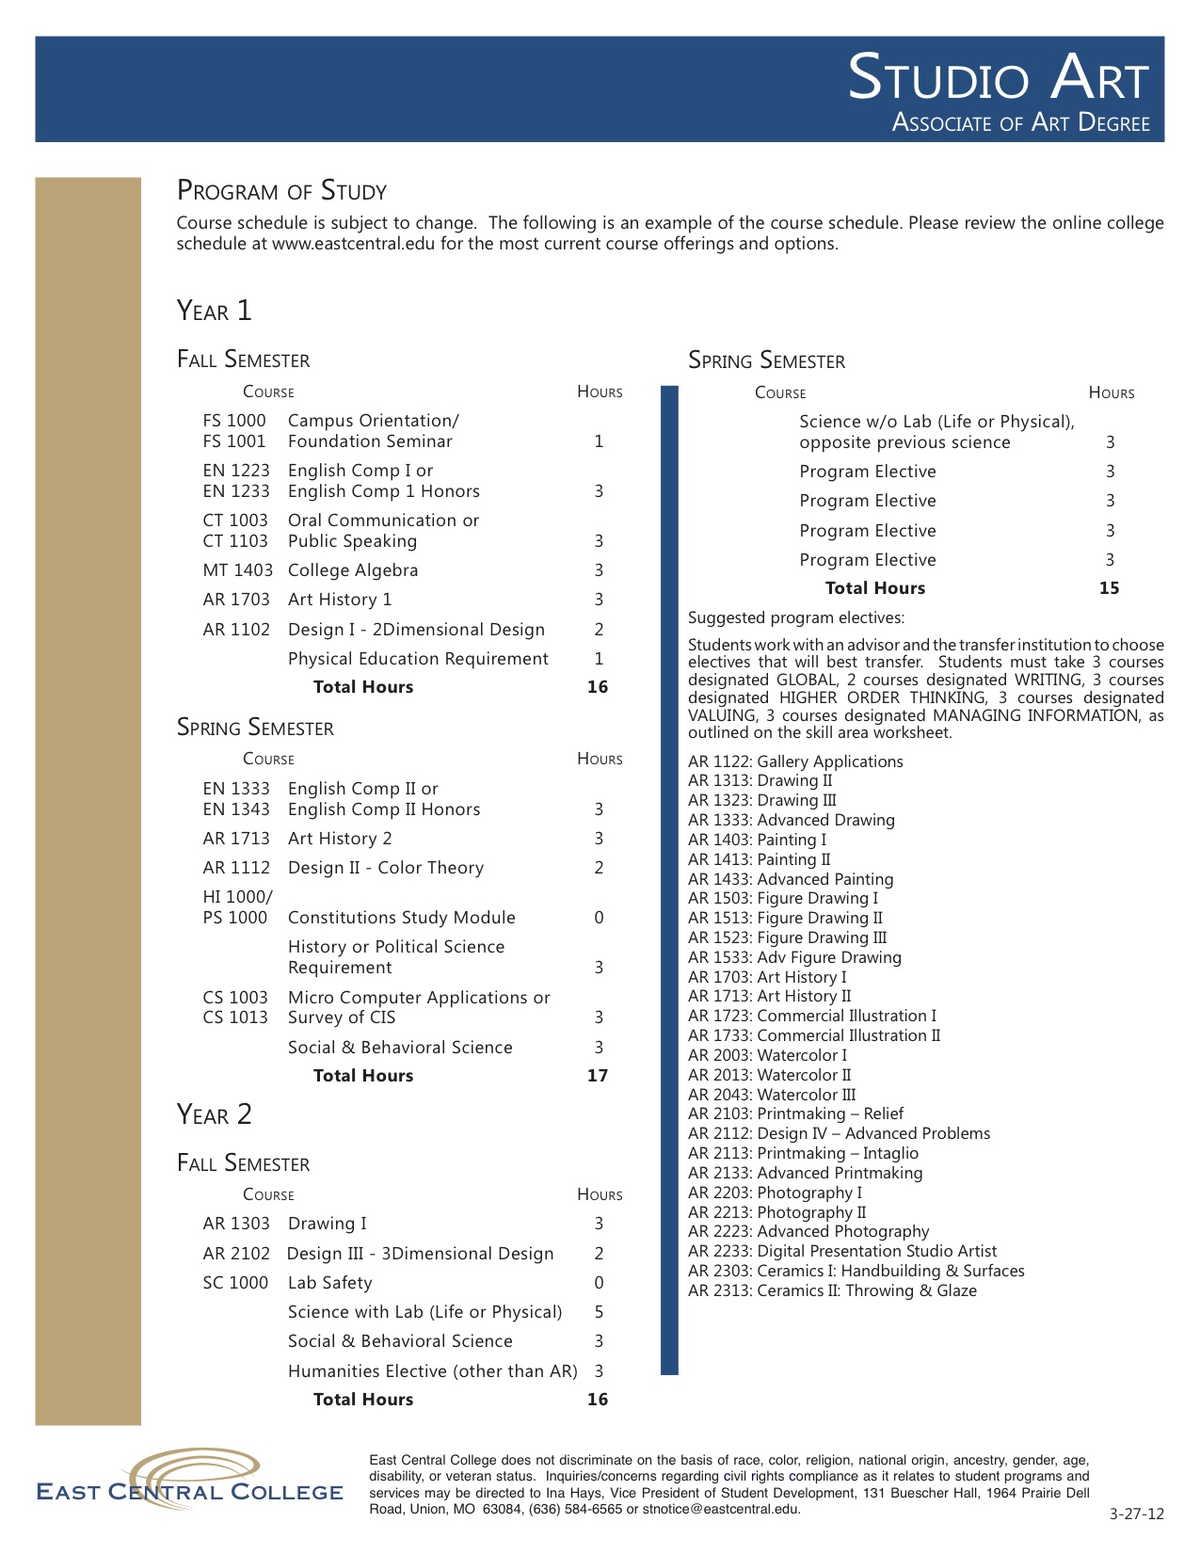

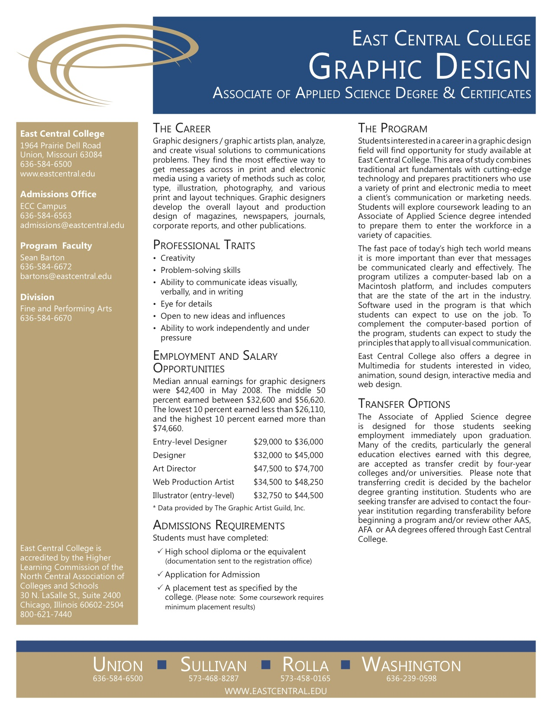

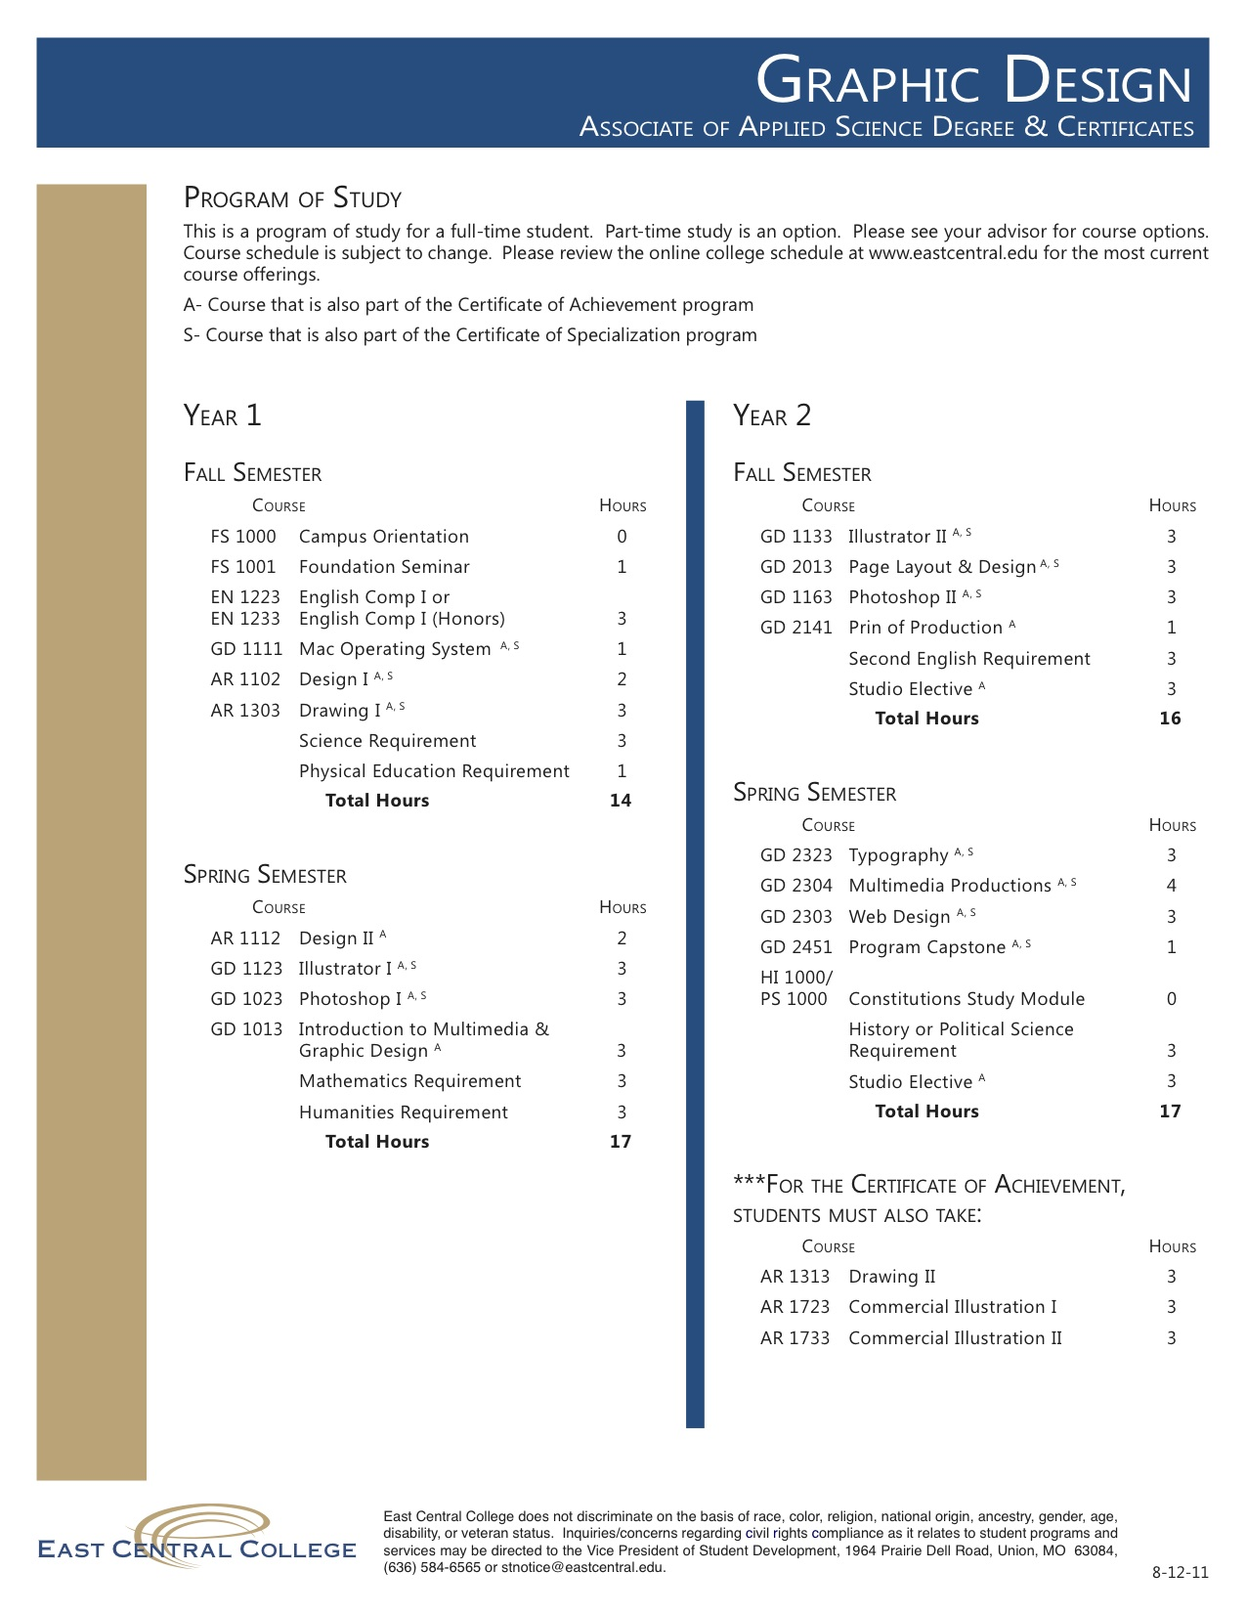

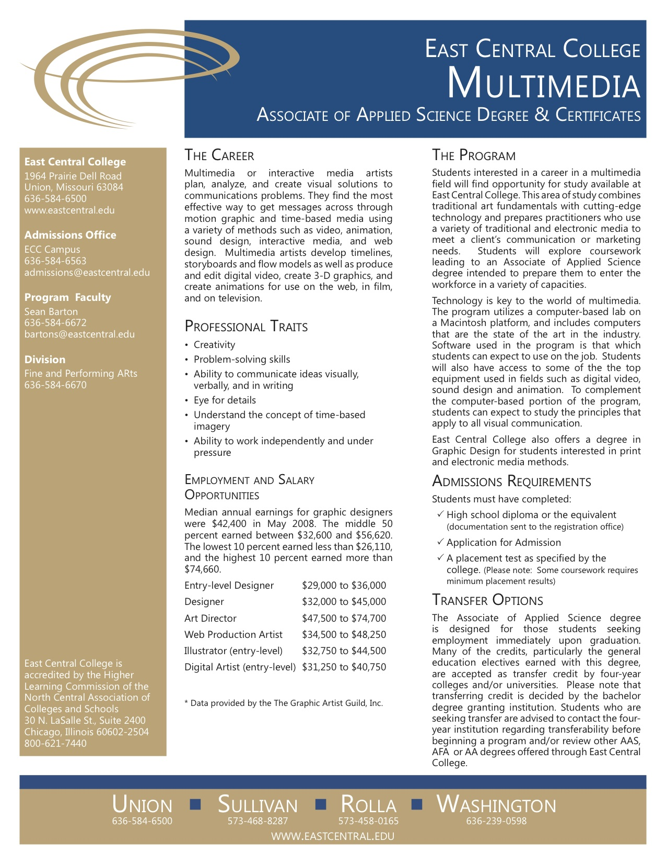

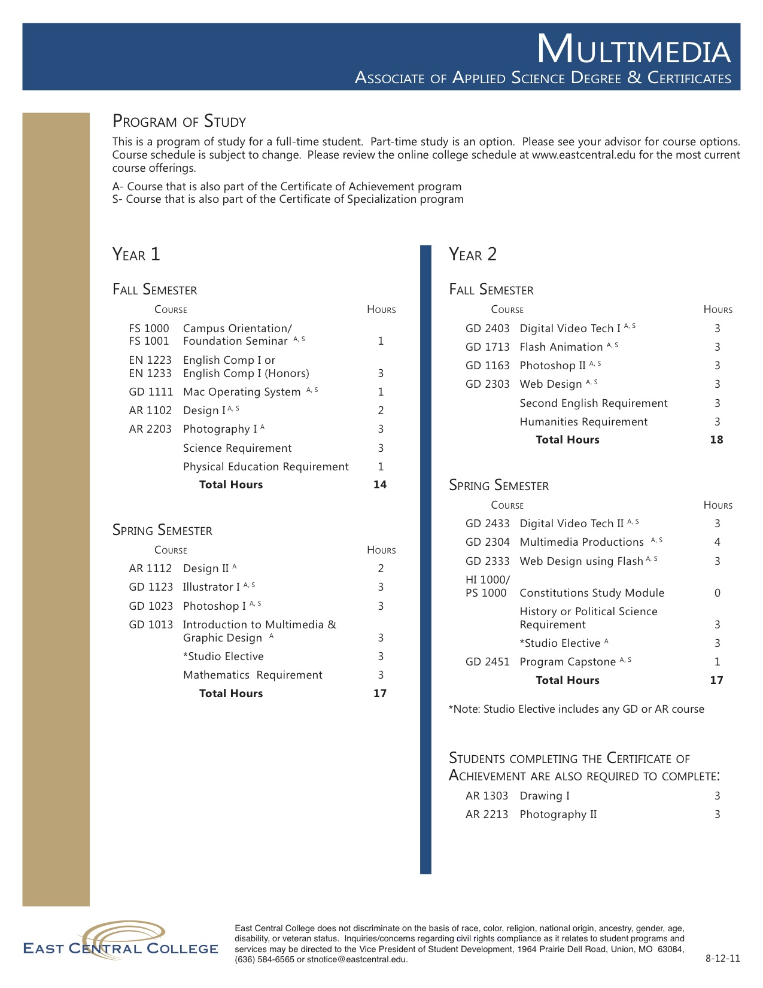

Fine Art Assessment Plan

Art Department Mission
The East Central College Art Department's mission is to provide a strong foundation rooted in the principles of art and design and foster a creative atmosphere fundamental to life long learning in which a student develops mastery of skills and techniques, develops critical and creative approaches to problem solving that are communicated in a visual context as well as in written and verbal format, becomes socially aware of trends and traditions of the larger art world both past and present in preparation for transfer.

Program Objectives | Assessment | CLO’s
* Use proper industry nomenclature | artist statement | communication
* Utilize technology to present and document their work for presentation | digital portfolio | communication
* Display an adequate level of professionalism in presentation of their work | student art exhibition | ethics & social responsibility
* Display critical thinking skills and concrete conceptual development | creation of a coherent body of work, iconography | critical & creative thinking
* Demonstrate a substantial engagement with historical concepts/techniques/artists/movements as well as a working knowledge of contemporary artists. | artist statement | communication, ethical & social responsibility, and critical & creative thinking

Review of Outcomes
Data collection - by full time and adjunct faculty at end of each semester
Data review & analysis - by full time faculty with adjunct faculty at the end of the academic year
Modifications to curriculum as needed to meet program goals
Continued participation in ECC CLO’s
Submit results and updated plans to Division Chair and Office of Instruction at the end of academic year

Program Review Cycle
Assess - AFA round 1
Assess - AA round 2
Assess - General Education offering (Art Appreciation & Art History) & Gallery round 3
Program Review - beginning Jan 2012, completion December 2012
NASAD - beginning Fall 2011, completion Spring 2014

Graphic Design Assessment Plan

Multimedia Program

Review of data received in 2010 Assessment Report

Learning/Teaching Styles that best worked for the students.

a. Demonstration/Visual examples 84% positive b. Self research 52% positive c. Personal Time w/ Instructor 80% positive d. text (not available for all classes) 28% positive e. team learning 60% positive

Other Relevant Information:
As per statements made on surveys or in emails sent with surveys

• Several projects need to be reviewed/edited/removed from curriculum

• In equipment-­‐heavy courses, more overview/review of equipment

• Self exploration seems to be more successful than was thought

• Students lack a true multimedia vocabulary/concepts when graduating

• Time management continues to be a huge problem

New Strategies/Adjustments to Program

• Intro to MM/GD needs more lecture, less projects
• Vocabulary must be integrated and tested for

• Extra work with the equipment in-­‐class

• New projects need to be developed for each class

• Video II becomes more about post-­‐production
• Fully establish a Capstone Rubric for Multimedia Portfolios/Reels

• Pre/Post tests and more written components in all courses
• Include more specific update/progress checks on work in progress

I. Actions to be taken in 2011-2012 Academic year

• Several projects need to be reviewed/edited/removed from curriculum
Projects/Assignments terminated Projects/Assignments Added/Edited

GD1013 | Hand-built Advertisement | Vocabulary lists/quizzes
GD1111 | Class to be Deactivated | Mac OS curriculum added to GD1013
GD1023 | N/A | More emphasis on web-prep for images
GD2451 | Creative piece/Standard resume design | Self-promotional piece/Mock interviews w/unknown interviewers/more creative resume design/Required business card/self I.D. and branding
GD2141 | Course deactivated/Kept in Four Rivers articulation as studio elective | N/A
GD2433 | Further assignments in Final Cut Pro | Switched to a complete Adobe After Effects curriculum on motion graphics

Art & Design Faculty

Full-Time Faculty

Adam Watkins, MFA Kent Institute of Art & Design – Canterbury, UK
Instructor of Fine Art
awwatkins@eastcentral.edu, 636.584.6652

Jennifer Higerd, MFA Fort Hays State University – Hays, KS
Instructor of Fine Art, Gallery Coordinator
jehigerd@eastcentral.edu, 636.584.6653

Sean Barton, MFA Memphis College of Art – Memphis, TN
Instructor of Graphic Design
bartons@eastcentral.edu, 636.584.6672

Elizabeth Manhart, MA Savannah College of Art & Design - Savannah, GA
Instructional Program Assistant, Graphic Design
manharte@eastcentral.edu, 636.584.6673

Adjunct Faculty

Robert Sullivan, MFA Fontbonne University – St Louis, MO
Adjunct Instructor of Fine Art
rpsulliv@adjunct.eastcentral.edu

Gary Powers, MFA University of Iowa, Iowa City, IA
Adjunct Instructor of Fine Art
grpowers@adjunct.eastcentral.edu

Annette Swafford Green, MFA Fontbonne University – St Louis, MO
Adjunct Instructor of Fine Art
ajgreen@adjunct.eastcentral.edu

Juanita Schuler, MAT Webster University – St Louis, MO
Adjunct Instructor of Fine Art
jschuler@adjunct.eastcentral.edu

Anne Griffith, MA University of Missouri, Columbia – Columbia, MO
Adjunct Instructor of Fine Art
amgr3441@adjunct.eastcentral.edu

Robert Goetz, MFA Washington University – St Louis, MO
Adjunct Instructor of Fine Art
rcgoetz@adjunct.eastcentral.edu

Rhonda Pierce, MSEd Missouri Baptist University – St Louis, MO
Adjunct Instructor of Fine Art
rlpierce@adjunct.eastcentral.edu

Christine Brandt
Adjunct Instructor of Graphic Design
cabrandt@adjunct.eastcentral.edu

Robert Leu, BFA Kansas City Art Institute – KC, MO
Adjunct Instructor of Graphic Design
leu@adjunct.eastcentral.edu

Art Scholarship Opportunities

Mid Missouri Fine Arts Society
Art Major
Sophomore
ECC District
Last year award was $500 for the year

Aaron Buchanon Memorial Scholarship
Art or education major
2nd yr student
ECC District
EFC
Renewable
Last year amount awarded $1000 for the year

Patron of Arts Scholarship
Art Major
HS GPA
College GPA
EFC
Renewable
Last year amount awarded $500.00 for the year

Larry Pogue Art Scholarship
Art Major
HS GPA
College GPA
Renewable
Last year amount awarded $1000.00 for the year

Marian Hatcher Scholarship
Art Major
Need based
GPA HS and College
Last year amount awarded $1000.00 for the year

Art Department Scholarship
Art Major
portfolio and written essay
$1000 tuition waver per semester

ART SCHOLARSHIP APPLICATION

To be considered for a scholarship, please follow these procedures:

- Complete and submit the FAFSA (Free Application for Federal Student Aid) at www.fafsa.gov
East Central’s School code is 008862.
2. Read all questions on this application carefully. Only those applicants completed in full will be considered.
3. Scholarship recipients must maintain a minimum enrollment of 12 credit hours and be an active member in
the Art Club and assist with all Art Department activities.
4. Applications must be postmarked no later than March 30.
5. Submit two sealed letters of reference from instructors or counselors familiar with your work and/or work
ethic.
- Submit a one page essay describing why you feel the visual arts are significant in our society.
- Submit a portfolio for review at our Portfolio Review day or make an appointment before March 30. You should present 12-15 examples of your work.

PERSONAL INFORMATION (please type or print legibly)

Last Name ______________________________________ First Name ___________________________ MI ______

SS# or Student ID # ______________________________ Date of Birth ________________________________

Street __________________________________________ City, State Zip __________________________________

Home Number (______)___________________________ Cell Number (______)_____________________________

E-mail __________________________________________________________________________________________

Age _______________ □ Married □ Single Number of Children ___________________

Last High School Attended _____________________________________ Graduation Date ___________________

Students Place of Employment ____________________________________________________________________

Honors & Awards Received _______________________________________________________________________

________________________________________________________________________________________________

________________________________________________________________________________________________

Extracurricular Activities __________________________________________________________________________

________________________________________________________________________________________________

________________________________________________________________________________________________

Major Field of Study ______________________________________________________________________________

When will you enter College? Year ________________________ Semester________________________________

Classification: □ New student □ Returning Student □ Transferring Student

List any awards, scholarships, or other financial aid which have been awarded to you to help defray college

expenses: ______________________________________________________________________________________

________________________________________________________________________________________________
________________________________________________________________________________________________

FAMILY INFORAMTION

Number of dependents in the household (including applicant): _________________________________________

Number in family who will be in college next year: ____________________________________________________

To be completed by Parents, Guardian or Student

Father/ Student Mother/Spouse

Name _______________________________________ Name ______________________________________

Address _____________________________________ Address ____________________________________

Occupation __________________________________ Occupation _________________________________

Employer ____________________________________ Employer ___________________________________

Monthly Income (all sources) ___________________ Monthly Income (all sources) __________________

To Be Completed By High School Principal or Counselor
(If you are not a recent high school graduate please disregard)

Please give your appraisal/recommendation on this applicant:

Cumulative GPA: ____________________________ Class Rank (if available): _____________________________

ACT/SAT Test Scores (if available): ________________________________________________________________

Please address the following in a reference letter for the applicant: leadership, extracurricular activites, work ethic and any other glowing information that comes to mind.

Do you recommend this applicant for a scholarship? □ Yes □ No

Signature of HS Principal or Counselor _____________________________________________Date ___________

NOTE: PLEASE ATTACH A SEVENTH (7TH) SEMESTER TRANSCRIPT

Mail to: Art Department
East Central College
1964 Prairie Dell Road
Union, MO 63084

ECC Art Gallery 2012-13 schedule

Summer 2012
1. Annie Scheumbaurer, Watercolor
May 21 - August 17

Fall 2012
1. Mark & Bambi Freeman, ceramics
August 23 - September 21
reception: Sept 21
workshop/artist talk - Sept 21

2. Craig Stephens, painting
September 26 - October 31
reception: October 5, 6-8 pm

3. Mid-Missouri Fine Arts Society
November 7 - December 5
reception: Nov 9, 5-7:30 pm

4. Gift of Art
opens on same night as Christmas Celebration
Dec 7 & 9 and Dec 10-12

Spring 2013
1. Kyle Chaput, printmaking
Jan 17 - Feb 15
reception: February 8, 5 - 7:30 pm
workshop: Feb 8(?)

2. Cathy Breslaw, sculpture
Feb 21 - April 4
reception: March 8, 5-7 pm
artist talk/ critique / etc: March 7 or 8

3. Four Rivers HS Art Show
April 7 - April 19
reception: April 7, 1-3 pm

4. ECC Juried Student Art Show
April 25 - May 10
reception: April 26 6-9 pm

Guidelines for Success in the Art Studio

Grading
Grading in Art courses is not arbitrary. Your semester’s grade is dependent on several variables:

1. Technical quality. Artisanship.
Mastery of hand skills associated with the discipline. Understanding of craft concerns as evidenced in the appropriate and skillful use of materials and process. Relevant precision and neatness of the work. Portfolio presentation. Talent.

2. Artistic quality of the work.
Display of understanding and use of basic design concepts (visual flow, composition, color usage) and basic skills such as drawing, composition and the like. Relationship of the concept to the execution. Appropriate exploitation of techniques, materials and process with relation to concept. Creative and imaginative solutions. Talent.

3. Quantity.
Extra trials, prototypes or experimentation. Extra work beyond the assigned problems. More elaborate or challenging interpretation of assignments.

4. Semester-long attendance and performance in critiques.
Understanding of concepts presented in class as reflected in verbal articulation. Punctuality of the work. Understanding of and follow-through on criticisms as reflected in subsequent work. Motivation and use of class time, effort to grasp concepts, willingness to work, outside readings, outside parallel projects, stamina, continuity, momentum, improvement.

Studio Art Myths
Talent
Talent does count. If a student has precociousness for a discipline area, they tend to do well because they like to spend time and thoughtful energy in the work of that discipline. The work, and consequently, the grade tend to follow. Those with intrinsic talent may think they can “pull something off” at the last minute, but often it backfires. Talent does not necessarily deliver a good grade. Expect to challenge yourself at a higher level.

Hard Work
Hard work alone does not necessarily achieve an “A”. Unlike other disciplines, however, hard can be taken in to account when a project fails. If the failure can be articulated and built upon, then the learning experience can be justified. Follow-up is key. Hard work does not mean putting in all the hours required for a project by staying up for an all-nighter just before a project is due. It means being consistent and prepared for the duration of a project.

The Idea, The Craft
Idea and craft are inextricably linked. While each aspect of a work may be discussed separately, in the end successful work is that which idea and craft are co-dependent. In other words: part of your idea, IS the craft. Your choice of materials, approach, formal means etc will revel the idea best.

It’s Subjective
Much of a grade is located in very quantifiable elements – time spent, preparedness, technical skill, quantity, and interaction. Many assignments, especially in introductory classes are designed to develop particular skills and ideas with a limited range of possible solution. Faculty is trained to understand and evaluate a wide range of approaches and can identify quality in works and approaches that are not personal favorites.

A – Mastery of course content at the highest level
Work showing student’s full involvement in assignment through exploration, research and learning. Work that surpasses the requirements of the assignment through the use of inventive thought.

B – Strong performance
Solid work, showing involvement with assignment.

C – A totally acceptable performance
Work that satisfies the requirements of the assignment shows effort but retains unresolved issues.

D – A marginal performance
Lowest Passing Grade/ Work that is poorly executed

F – Unacceptable performance
Failure/ Missing or incomplete work

Profile of an “A” Student
This student attends class, arriving on time, prepared with materials for the day’s assignment and outside work completed. This person participates in all aspects of class, focusing on assigned work, is cooperative and studies assigned readings. The “A” student consistently produces excellent work. The good craftsmanship is evident in the care and precision the student uses in the execution of work. The comprehension of the project is revealed in the work, understanding the basic concepts of the assignment. He/ She uses inventive thought to create his/her own version of the assignment, while following the guidelines and principles established in class. During critique, the student expresses thoughtful comments to others. The effort and growth that the “A” student has achieved is obvious at the end of the semester.
Studio Rules for a Creative Space

- Remember the Golden Rule: Treat others as you would like to be treated.
- Everyone working in the studio is responsible for the condition of the space.
- When finished working, clean your area and any studio equipment or tools you used.
- Return tools (cleaned!) to their proper location after you use them.
- Label your tools using permanent marker. Before you borrow someone else’s tools, ask permission.
- Be fair in your use of table surfaces and storage areas. Consolidate and share space with others.
- Ask permission to use equipment and use it properly. It is expensive to fix and difficult to replace.
- Plan ahead. Allow ample time for deadlines.
- Limit noise. Keep loud conversations and cell phone use outside the studio.
10. Show consideration when an instructor is lecturing or helping another person.
11. Table saws, grinders, and similar studio equipment may only be used with art faculty supervision.
12. Wear appropriate safety equipment when using tools, such as goggles, gloves, etc.
13. All students are expected to adhere to the ECC Student Conduct Policy as outlined in the student handbook.

_____________________________________________________________________________________________________ student signature date

_____________________________________________________________________________________________________ administered by date

Graphics Lab Rules
You are in college. You will be treated and respected as an adult, so long as you do the same. Because of the nature of discussions involved in this class, it is imperative that we respect each other’s opinions and values. Discipline problems are not tolerated. Any discipline problem will be dealt with swiftly and permanently by removing the student from the class. This statement is the first and last that will ever be spoken on the topic.
The Rules
NO cell phones on during class /NO text messaging
(failure to follow this will result in confiscation of phone until class is over)
NO Food at anytime allowed in the labs.
NO drink in class near the computers. All beverages must be in approved containers and placed in your bag on the floor. Approved containers are the following: Drinks in bottles with screw caps, water bottles with plug caps, coffee mugs with screw top cover.
NO disrupting class.
NO sitting in on classes you are not enrolled for without the teacher’s approval
NO loitering in classroom before or after your class is set to begin
HEADPHONES must be used for all audio media.
NO games of any kind are allowed on our computers.
NO television shows, movies, music videos, or animations allowed unless being used as research for a Graphic Design/Multimedia class. Your instructor will know the difference, so don't try and pan off watching old episodes of LOST as 'research'.
PRINTING: Students can only print to the B&W HP laser printers located in each room. Printing in the Graphic Design labs are for Graphic Design related projects only. NO printing of term papers, or other assignments for other classes is allowed. Use the Library, Learning Center, or one of the various other computer labs for these print jobs. If you are printing multiple pages, please print double-sided to save paper. There is a limit of 20 pages per day that each student can print. After you reach your limit, the system will lock you out. Instructors and Lab Technicians can help you with double-sided printing.
COLOR PRINTING: Students can get color prints from the lab technicians. During Open Lab Time, a student lab technician will be in charge of printing all color work. They are to print only. All page-setups, color corrections, file types, etc., is the responsibility of the artist. The Lab Technician will not correct any mistakes you have made prior to printing the piece. You will pay the technician at time of printing. The technician schedule will be in place within the first three weeks of the semester.

OPEN LAB TIME: Times for Open Lab are posted outside of each class room. Open Lab time was created for students to work on their Graphic Design/ Multimedia homework, since most of our students do not own the technology and software they need at home. It is to be used as such. Open Lab time is not for use to pass the time while waiting on other classes. We are not a bus station.
EQUIPMENT CHECK OUT: All equipment available for checkout has it’s own rules. They will be posted in the department.
HOME DIRECTORY DISK SPACE: Each student enrolled in a Graphic Design class will have a designated disk space of 10GB (gigabyte).
SUPPLIES: Items like staplers, tape, tacks, pens, notebooks, paper clips, etc, are your responsibility. We don’t supply these to students.
The Three-Strike Rule: The first offense, you will be given a warning. The second time of the offense you will be asked to leave and the third time, you may get a reduction in your final grade or fail the course completely.

Useful Language of the Art and Design Studio
LINE
Expressive/Gestural: A vigorous drawing that captures movement and the overall orientation of an object, rather than describing specific detail. Often used as a basis for figure drawing.
Implied: 1. A line that is suggested by movement or by a gesture rather than being physically drawn or constructed. 2. A line that is suggested by the positions of shapes or objects within a design. With either form of implied line, the viewer mentally connects the points.
Actual: Lines that are physically present in a design.
Curvilinear: A line dominated by curves and flowing lines.
Rectilinear: A predominantly straight line or a line that follows hard angles.
Contour: A line that describes the edges of a form and suggests three-dimensional volume.
Directional: A line, either actual or implied, that leads the viewer in a specific direction easily creating movement in a composition.

Line can show
Movement: perceived action in a composition or creating a composition that causes the viewer to physically move their gaze throughout the composition
Density: The extent to which compositional parts are spread out or crowded together. The visual connections that occur easily in a high-density composition are often less obvious in a low-density composition.
Closure: the mind’s inclination to connect fragmentary information in order to create a completed form. Closure is an essential aspect of Gestalt (form, all parts operating as part of the whole) psychology.
Direction: see movement
Definition: the degree to which a form is described.
These are principles of design and line can be an effective element to achieve these principles.

SHAPE
Format: outer edge of a design providing the first shape in a composition
Negative Shape/Ground: any clearly defined area around a positive shape; the receding shape or ground area in a figure-ground relationship. A shape created through the absence of an object rather than through the presence of a shape
Positive Shape/Figure: the principal or foreground shape in a design; the dominant shape or figure in a figure-ground relationship
Figure/Ground Reversal: an arrangement in which positive and negative shapes alternatively command attention. Also known as positive and negative interchange.
Rectilinear: dominated by straight lines and angular corners
Curvilinear: dominated by curves and flowing lines
Geometric: distinguished by their crisp, precise edges and mathematically consistent curves.
Organic: shape based on forms from the natural world or suggestive of living organisms. Also known as biomorphic shape.
Shape: In two-dimensional design a shape that seems three-dimensional is called a volume.
Degrees of Definition: high definition creates strong contrast between shapes and tends to increase clarity and immediacy of communication. Low definition shapes, including gradations, transparencies and soft-edged shapes, can increase the complexity of design and often encourage multiple interpretations.

TEXTURE creates a bridge between two-dimensional and three-dimensional design
Texture: the surface quality of a two-dimensional shape or a three-dimensional volume
Tactile Texture: can actually be felt
Visual texture: created using multiple shapes or through the simulation of physical texture.
Density: the extent to which compositional parts are spread out our crowded together.
Orientation: the angle at which a visual element is positioned.
Illusory texture: adds weight to shapes and can suggest three-dimensional volume.

SPATIAL SYSTEMS
Overlap: placement of one shape in front of another to create the illusion of space
Scale/Size Variation: a size relationship between two separate objects, such as the relationship between the size of Mount Rushmore and a human visitor to the monument
Definition/Atmospheric Perspective: a visual phenomenon in which the atmospheric density progressively increases, hazing over the perceived world as one looks into its depth. Overall definition lessens, details fade, and contrasts become muted. In a landscape a blue mist descends
Multiplication: as an object moves, it sequentially occupies multiple spaces. Visual multiplication helps capture such movement.
Pattern: created when shapes repeat over an extended area, can be used to unify many small bits of visual information
Discordance: created when repetition seems to have no apparent organization
Rhythm: created when multiple parts are presented in a deliberate pattern

ORGANIZATION
Gestalt: emphasizes the importance of unite, connection, and completion, indeed, “whole” is an appropriate English translation of this German word. According to this theory, visual information is understood holistically before it is examined separately. Furthermore, the mind can absorb only a limited number of disparate units within an image. An image composed of units that are unrelated in size, style, orientation, and color will appear incomplete and unresolved. To achieve unity, the designer creates deliberate relationships among disparate visual elements.
Containment: relationships automatically occur when visual elements share a common container. The outer edge of the design provides this container and helps to define the negative space around each positive shape.
Proximity: the distance between visual elements. Shapes or volumes placed close together are easily unified, while more distant shapes or volumes read as separate units.
Fusion: occurs when shapes or volumes are placed so close together that they share common edges.
Continuity: creates a fluid connection among compositional parts.
Closure: makes it possible to communicate using implication. Freed of the necessity to provide every detail, the artist can convey an idea by using suggestion, rather than description. When the viewer completes the image in his or her mind, it is often more memorable than a more explicit image.

Academic Calendar for Fall, 2012
July 13 Campus Orientation
July 25 Fall Tuition and Fees Due
August 3 Campus Orientation
August 13 Campus Orientation
August 15 Fall Classes Begin
September 3 Labor Day - College Closed
October 1 – October 5 Mid-Semester Week
October 9 Spring Mid-Semester Grades Due
October 11 – October 12 Fall Break
November 2 Last day to withdraw from regular semester course with a W grade.
November 21 – November 23 Thanksgiving - College Closed
December 6 Classes End
December 7 Reading Day
December 10 – December 13 Final Exams
December 17 Fall Final Grades Due
December 24, 2012 – January 1, 2013 College Closed
Academic Calendar for Spring, 2013

Monday, December 17 Spring Tuition and Fees Due
Monday – Tuesday, December 24, 2012 – January 1, 2013 College Closed
Thursday, January 10 Campus Orientation
Monday, January 14 Spring Classes Begin
Monday, January 21 Martin Luther King Day - College Closed
Monday – Friday, March 4 – March 8 Mid-Semester Week
Tuesday, March 12 Spring Mid-Semester Grades Due
Monday – Friday, March 18 – March 22 Spring Break
Friday – Saturday, March 22 – March 23 Music Festival
Friday, March 29 Good Friday - College Closed
Friday, April 12 Last day to withdraw from regular semester course with
Wednesday, May 8 Classes End
Thursday, May 9 Reading Day and Commencement
Friday, May 10 Reading Day
Monday – Thursday, May 13 – May 16 Day and Evening Final Exams
Tuesday, May 21 Spring Final Grades Due
Monday, May 27 Memorial Day - College Closed

Academic Calendar for Summer, 2013

Monday, May 13 Summer Tuition and Fees Due
Monday, June 3 Summer Session Begins
Thursday, July 4 Independence Day - College Closed
Friday, July 5 Independence Day - College Closed
Thursday, July 25 Summer Session Ends
Tuesday, July 30 Summer Final Grades Due
Thursday, August 8 Fall Semester Campus Orientation

Course Descriptions from ECC Course Catalog
Course Catalog: Art
AR 1102 | 2.0
Design I-Two Dimensional Design
A studio course that studies the basic elements and principles of two-dimensional design through a series of assigned problems.
Prerequisite: None HFA
AR 1112 | 2.0
Design II-Color Theory
A studio course that studies color, exploring various color theories and the historical application through a series of problems.
Prerequisite: None HFA
AR 1122 | 2.0
Gallery Applications
This is a required course for all art majors with a focus on the business of art. Students will establish a future schedule for the ECC Gallery and implement the schedule of the current year. Focus will be on receipt and installation of artist's work, preparing an opening reception, publications, dismantling and return shipping of the exhibition. Students will also create a personal portfolio, artist statement and professional resume in preparation for future portfolio reviews and/or presentation to a gallery. HFA
AR 1203 | 3.0
Art Appreciation
This course is intended to stimulate students' visual, cultural, and intellectual awareness by introducing design vocabulary, conceptual awareness, analytical skills, and methods of the creative process. Students will also be introduced to a general overview of global artistic activities through the ages and consider the importance of visual arts in their contemporary lives. GLB, VAL, HFA
AR 1303 | 3.0
Drawing I
A studio course in drawing. The student will be introduced to methods and techniques based on the elements and principles of design. The emphasis will be the development of observational and compositional skills, and a heightened sense of creativity.
Prerequisite: none
AR 1313 | 3.0
Drawing II
A continuation of Drawing I focusing on refinement of observational and compositional skills, and development of an individual approach to drawing problems.
Prerequisite: AR 1303
AR 1323 | 3.0
Drawing III
A continuation of Drawing II, concentrated practice in observational drawing. Emphasis will be placed on compositional skills necessary to create finished works of art with an individual style.
Prerequisite: AR 1313
AR 1333 | 3.0
Advanced Drawing
Independent study into the exploration of style and content through drawing, perhaps relating to other fields or processes such as painting and printmaking.
AR 1403 | 3.0
Painting I
An introduction to the materials and techniques of oil painting intended to develop technical, expressive, and conceptual abilities. Comprehension and utilization of compositional and observation skills will be stressed.
Prerequisite: None
AR 1413 | 3.0
Painting II
A continuation of Painting I, in which the student will further develop technical abilities in oil painting, stressing color and spatial relationships, and a refinement of observational skills. Deeper exploration into personal expression and painting as communications.
Prerequisite: AR 1403
AR 1433 | 3.0
Advanced Painting
Independent study into the personal exploration of style through painting. More emphasis on narrative content than in lower levels.
AR 1503 | 3.0
Figure Drawing I
An introduction to drawing from the human figure. An analysis of structure and how it relates to overall form. Emphasis on observational skills to achieve correct proportion, and sensitivity to the subtleties of the human figure.
Prerequisite: None
AR 1513 | 3.0
Figure Drawing II
A continuation of Figure Drawing I, drawing from the human figure. Refining observational and compositional skills through a more personal approach to the subject matter.
Prerequisite: AR 1503
AR 1523 | 3.0
Figure Drwg III
A continuation of Figure Drawing II, an advanced study in drawing the human figure. Emphasis will be on technical skill, individual expression and attempts to define one's style.
Prerequisite: AR 1513
AR 1533 | 3.0
Adv. Figure Drawing
Advanced study in drawing the human figure, with emphasis on exploration through the use of different media and definition of personal style.
Prerequisite: AR 1523
AR 1703 | 3.0
Art History I
A historical study of art, tracing its development from prehistoric times to the eighteenth century. Emphasis is on the study of the growth and development of art forms and movements, leading to an understanding of the relationship of art to the historical periods. GLB, VAL, HFA
Prerequisite: None
AR 1713 | 3.0
Art History II
A historical study of art tracing the development of art from the 18th century through contemporary times. Emphasis is placed on individual artists and art movements. GLB, VAL, HFA
Prerequisite: None.
AR 1723 | 3.0
Commercial Illust I
Explore the variety of drawing and painting methods and materials used by professional designers and illustrators. Refining will enhance creative expression of drawing and painting techniques and the investigation of various media. Students will be introduced to a variety of design and illustration techniques and procedures.
AR 1733 | 3.0
Commercial Illus II
A continuation of Commercial Illustration I. Emphasis is on gaining proficiency with media, developing the ability to create illustrations and produce them in print form.
Prerequisite: AR 1723
AR 2003 | 3.0
Watercolor I
The study of watercolor painting with emphasis on color, composition, and pictorial expression with experimentation in varied methods of watercolor painting. Studies will include washes and brush control.
Prerequisite: None
AR 2013 | 3.0
Watercolor II
A continuation of the study of watercolor painting with emphasis on color, composition, and pictorial expression with experimentation in varied methods of watercolor painting. Studies will include washes and brush control.
Prerequisite: AR 2003 or consent of instructor.
AR 2043 | 3.0
Watercolor III
A continuation of the study of watercolor painting with emphasis on personal creative structure, topics and problems, and contemporary painting.
Prerequisite: AR 2013 or consent of instructor.
AR 2102 | 2.0
Design III - Three Dimensional
An introduction to three-dimensional work, exploring the spatial qualities of mass, shape, volume. HFA
AR 2103 | 3.0
Printmaking-Relief
An introduction to the history, materials, and techniques of printmaking intended to develop technical and expressive abilities. Relief processes will be covered, as well as monotype. Other areas to be covered included executing an edition of prints, matting and framing for presentation.
Prerequisite: None.
AR 2112 | 2.0
Design IV - Adv. Problems
Advanced problems in various aspects of design, focusing on conceptual development.
Prerequisite: AR 2102 HFA
AR 2113 | 3.0
Printmaking-Intaglio
An introduction to the history, materials, and techniques of printmaking intended to develop technical and expressive abilities. Intaglio processes will be covered, as well as monotype. Other areas to be covered include executing an edition of prints, matting and framing for presentation.
Prerequisite: None
AR 2133 | 3.0
Advanced Printmaking
Independent intensive exploration into the process of choice. The student will create a "suite" of prints, working in a series.
Prerequisite: AR 2103 and AR 2113
AR 2203 | 3.0
Photography I
A course dealing with the basics and principles of photography, primarily black and white, including the mechanical and visual aspect for beginning photographers. Darkroom skills of black and white film developing and printing are taught.
Prerequisite: None, 35mm camera.
AR 2213 | 3.0
Photography II
A course approaching photography primarily from the creative visual aspect. The course is meant to increase the photographer's awareness and sensitivity, and at the same time refine basic mechanical skills.
Prerequisite: AR 2203 or consent of instructor, 35mm camera.
AR 2223 | 3.0
Advanced Photography
A continuation of Photography II with advanced study in black and white photographic methods, composition, and dark room techniques.
Prerequisite: AR 2213
AR 2233 | 3.0
Digital Pres. Studio Artists
This is a required course for all art majors with a focus on digital applications pertinent to a successful career as a visual artist. Students will learn basic skills in visual programs as well as how to document and prepare their work digitally. HFA
AR 2303 | 3.0
Ceramics : Handbuilding & Surfaces
An introduction to clay as a medium of expression using ancient and modern techniques of forming clay objects. A variety of surface decoration techniques will be explored, as well as an introduction to basic industry nomenclature and a history of the medium. Firing techniques including oxidation, reduction, raku, and primitive methods are taught. Development of studio safety, technical, expressive, and conceptual abilities are stressed.
Prerequisite: None
AR 2313 | 3.0
Ceramics II: Throwing & Glaze
A continuation of Ceramics I adding to students abilities with the introduction of the wheel. Students will explore the concepts of function and personal expression by producing a series of works. Students will also be introduced to the sciences of glaze calculations through a series of controlled experiments. Emphasis will be placed on studio safety, technical ability, historical precedent and personal expression.
Prerequisite: AR 2303
AR 2333 | 3.0
Advanced Ceramics
A self directed learning experience for students. Emphasis is on continued individual research and production methods. Course of study will include preparation for scholastic continuation in ceramics. Development of technical, expressive, and conceptual abilities are stressed.
Prerequisite: AR 2302 and AR 2313
AR 2403 | 3.0
Sculpture I
An introduction to sculpture stressing the elements of sculptural form. Various materials and construction methods used in the sculptural field of study are emphasized. Development of technical, expressive, and conceptual abilities are stressed.
Prerequisite: None.
AR 2413 | 3.0
Sculpture II
A continuation of the study of the elements of sculptures stressing the creative use of materials and construction methods. Development of technical, expressive, and conceptual abilities are stressed.
Prerequisite: AR 2403
AR 2701-2705 | 1.0-5.0
I.S.-Art
A specialized program of study directly related to the department's area of expertise. The course is arranged between a faculty member and student and takes into consideration the needs, interests and background of the student.
Prerequisite: Consent of instructor
AR 2711-2715 | 1.0-5.0
Special Topics-Art
Courses are offered to accommodate special interests of students and/or faculty. Typically, the course will cover new material not currently contained in the curriculum at ECC.
Prerequisite: None

Course Catalog: Graphic Design
GD 1013 | 3.0
Intro Multimedia & Graphic Design
This course will present students with a number of "tricks of the trade" used in the fields of Graphic Design and Multimedia. These will include equipment overviews, creative thinking projects, storyboarding, quality print output, and sound design. Students will be encouraged to explore non-traditional and artistic design styles to better market themselves in the job market.
Prerequisite: None
GD 1023 | 3.0
Photoshop I
This class offers an introduction to the concepts, processes, and software which are fundamental in creating and editing digital images. Basic and intermediate skills will be taught using Adobe PhotoShop. Student will explore color separation, best practices for creating Web images, including animated GIFs and preparation of images for both print and digital output.
Prerequisite: None
GD 1104 | 4.0
Introduction to Media & Design
This course will cover topics crucial to a career in Graphics not covered in other courses. Students will be introduced to the MAC Operating System, through lecture, demonstration, and hands-on-experience. Students will also learn "tricks of the trade" when dealing with traditional and technological options and their uses to create graphic art. In addition, students will be introduced to the technologies uses to create audio designs for time-based media. Finally, students will cover the overall workings and equipment of Graphic Design.
Prerequisite: None
GD 1111 | 1.0
Working with MAC OS
A course designed to introduce the student to the MAC O/S, through lecture, demonstration, and hands-on experience.
Prerequisite: None
GD 1123 | 3.0
Illustrator I
This course offers an introduction to the industry standard tools used to create graphical designs and text used in both the print and electronic based commercial media. Students will gain beginning/intermediate skills using Adobe Illustrator - the leading vector based illustration tool. Students will be gaining hands on experience with digital drawing tablets and multi-electronic output will also be addressed.
Prerequisite: None
GD 1133 | 3.0
Illustrator II
A continuation of Illustrator I - Students will be taking their skills in Adobe Illustrator to the intermediate/advance levels. An emphasis on layout, design, color schemes, page composition and typography will be applied. Students will explore creative combinations of vector and raster based images. The class will wrap up with "How to build a breath-taking digital portfolio."
Prerequisite: GD 1123
GD 1163 | 3.0
Photoshop II
This course will present to students more sophisticated studio techniques in digital imaging, intermediate/advance working skills using Adobe PhotoShop, introduction to the uses of third party filtering systems, as well as building a breath taking digital portfolio.
Prerequisite: GD 1023
GD 1713 | 3.0
Flash Animation
This course focuses on basic skills in animation using web animation technology. Students will gain knowledge of subjects ranging from story development to final output and compression for web viewing. Students will work with elements of visual physics such as light and shadow, locomotion, and illusionary three-dimensional space. Students will be focusing on animation and audio for the web using Adobe Flash.
Prerequisite: None
GD 2013 | 3.0
Page Design & Layout
This course covers the basic concepts and tools of desktop publishing and page design by using Quark Xpress and Adobe InDesign software.
Prerequisite: GD 1023, AR 1102, AR 1112
GD 2143 | 3.0
Principles of Production
This course provides a hands-on study of print production mechanics and techniques. Emphasis is placed on offset printing preparation, paper characteristics, inks, darkroom procedures and bindery.
Prerequisite: None.
GD 2153 | 3.0
Corporate Identity & Branding
Students will create or choose a client, an institution or company and then research, plan a strategy and design brand marks (e.g., symbols and/or logotypes) for their client. They then will refine these designs and apply them on a variety of items. There will be weekly critiques and examples. By the end of the semester, each student will have completed designs and applications for items such as stationery systems, magazine ads, a standards manual, trade show signage, a corporate product brochure, point-of-purchase display, packaging and Web pages. Students will submit preliminary sketches and prepare finished portfolio pieces. Emphasis will be placed on the core fundamentals of branding, effectiveness of the designs on items and control of a visual identity program.
Prerequisites: AR 1102, AR 1112, GD 1023, GD 1123
GD 2163 | 3.0
3-D Modeling
Students enrolled in 3-D Modeling will be learning the fundamental aspects of working in a 3-D work space. This includes learning to navigate a 3-D working space, understanding what the basic building blocks of a 3-D object are, and how they can be used to create more complex objects. Students will learn about how a 3-D objects is textured and rendered into a photo in addition to using virtual lights to light the modeled objects. Students should also expect to have a full understanding of the rendering process and how the computer generates the final image.
Prerequisite: GD 1023
GD 2173 | 3.0
Package Design
Package Design course will explore how "graphics" impact the success or failure of packaging appeal. The psychology of color, typography and imagery will be explored in ways that affects the consumer in their purchasing of products. Students will study ways paper cartons are folded to create basic shapes as well as exotic ones. Plastics, metals and glass will also be studied for their use in packaging various items. Students will take their sketches and develop them into 3D prototypes. They will explore innovative forms of packaging for various products as well. The target market, place of sale and price will be discussed and evaluated. The history and technologies of packaging thru the ages will also be reviewed.
GD 2223 | 3.0
Digital Photography
This course introduces students to the world of professional photography. Students will learn to use professional photography equipment to take the best possible photographs. Focus will be placed on learning to create a digital workflow for dealing with the large number of photographs that professional photographers process on a daily basis. Emphasis will be placed on having properly configured equipment at the time of the shoot to minimize the time spent in post production. The class will require a significant investment of time outside the class.
Prerequisite: AR 2203 Co-requisite: GD 1023 HFA
GD 2303 | 3.0
Web Design I
This class will cover the principles of HTML, CSS and good web design. Best practices using Adobe Dreamweaver and Adobe Photoshop for developing websites, testing and trouble-shooting websites and resources for problem-solving will also be covered. Design briefs, HTML5, CSS3 and SEO may be covered if time permits.
Prerequisite: GD 1023
GD 2304 | 4.0
Multimedia Productions
This course creates for students a "real life" production work situation. Students will be dealing with real "clients" and fulfilling responsibilities as account executive, production manager, graphic artist, multimedia author as well as other essential job titles. They will deal with issues like budgets, deadlines, hardware/software troubleshooting, time management, prioritization, and marketing.
Prerequisite: GD 1013, AR 1102, GD 1023, GD 1123.
GD 2323 | 3.0
Typography
This course covers the fundamentals of typography, its theory, practice, technology, and history. Studies range from introductory through current uses of typography. Exercises include the study of letterforms, type design, typographic expression and communication, type with image, proportion and grids, hierarchy, legibility, etc. The course will also serve to introduce the student to the department's technical facilities and will increasingly utilize the various type generation and graphic reproduction systems available.
Prerequisite: GD 1123.
GD 2333 | 3.0
Web Design Using Flash
Macromedia Flash is the professional standard for producing interactive user experiences on the web. Flash continues to add more advanced levels of interactivity and controls for animation. Students will learn basic techniques in action scripting for use in cutting-edge websites that focus on communication as well as design.
Prerequisite: GD 1023, GD 1163, GD 1713
GD 2403 | 3.0
Digital Video Tech I
This course introduces students to the technology used to create and edit digital video. Students will gain hands on experience shooting and editing video footage using both digital and analog video cameras. Editing will be done using Adobe Premiere on a Macintosh G3 DV workstation. Edited video will be output to a Digital VCR. Audio edition will also be addressed.
Prerequisite: None.
GD 2433 | 3.0
Digital Video Tech II
A continuation of Digital Video Techniques I - this course will emphasize content and production quality as well as optimization for delivery over the Internet. Integration and animation of 2D graphics, photographs and 3D objects will also be explored. Students will be using Adobe Premier as well as Adobe AfterEffects to accomplish high quality digital video projects.
Prerequisite: GD 2403
GD 2451 | 1.0
Program Capstone-Gr Design/Multimedia
This course is designed to provide students with the skills for seeking employment (to manage their careers effectively). Topics covered include conducting a job search; interviewing techniques, employment correspondence; acquiring web based skills and resume and portfolio development for job search and career advancement. Students will also demonstrate technology and academic proficiency (complete WorkKeys assessment). The course should be taken the last or next to the last semester prior to graduation.
Prerequisites: GD 1013, GD 1023, GD 1111, GD 1123, GD 1133, GD 1163, as well as their program requirements.
GD 2463 | 3.0
Web Design II
This class is a continuation of Web Design I. The class will learn more about HTML5 and CSS3, how to develop a site for both mobile and desktop, and creating a site with a content management system, the use of Google analytics and SEO. E-commerce may be covered if time permits. The final class project will be a portfolio site featuring the students’ work.
Prerequisite: GD 1023, GD 1713 and GD 2303
GD 2603 | 3.0
Multimedia Design Internship
This course includes a supervised work experience in the Multimedia Design field. A minimum of 150 clock hours is required. The work experience and criteria will be coordinated between the college instructor, student and cooperating employer.
Prerequisite: This course should be taken in the student's last semester.
GD 2613 | 3.0
Graphic Design Internship
This course includes a supervised work experience in the graphic design field. A minimum of 150 clock hours is required. The work experience and criteria will be coordinated between the college instructor, student, and cooperating employer.
Prerequisite: This course should be taken in the student's last semester.
GD 2701-2705 | 1.0-5.0
I.S.-Graphic Design
A specialized program of study directly related to the department's area of expertise. The course is arranged between a faculty member and student and takes into consideration the needs, interests and background of the student.
Prerequisite: Consent of instructor
GD 2711-2715 | 1.0-5.0
Special Topics
Courses are offered to accommodate special interests of students and/or faculty. Typically, the course will cover new material not currently contained in the curriculum at ECC.
Prerequisite: None

Supplemental Information From the ECC Student Handbook

Mission, Vision and Purpose
ECC Vision Statement
East Central College will connect its community to its future.
ECC Mission Statement
East Central College will provide an environment for lifelong learning.
ECC Purpose Statements
East Central College, in fulfilling its mission, will:
- Provide associate degree programs and coursework to prepare students for transfer to baccalaureate institutions.
- Provide associate degree and certificate programs to prepare students with requisite career skills to enter the work force.
- Prepare students in core academic areas for success in college level studies.
- Surround its academic programs with student development opportunities and learning support.
- Be a center of cultural activities, providing enrichment to the community.
- Enhance student learning through student activities, service learning and community activities.
- Be accessible to all students.
- Provide business and industry training in support of regional economic development.
- Offer continuing education and personal enrichment opportunity to the community.

Common Learning Objectives
The following common learning objectives will be achieved by all students who complete a cohesive program of study at East Central College:
- Communication
- Creative/Critical Thinking
- Ethics and Social Responsibility

NOTICE OF NON-DISCRIMINATION
Applicants for admission and employment, students, employees, and sources of referral of applicants for admission and employment are hereby notified that East Central College does not discriminate on the basis of race, color, religion, national origin, ancestry, gender, age, disability, or veteran status. Inquiries related to employment practices may be directed to Human Resources Director, 005 Classroom Building MP, telephone number 636-584-6712 or hrnotice@eastcentral.edu.
Inquiries/concerns regarding civil rights compliance as it relates to student programs and services may be directed to the Vice President of Student Development, 131 Administration Building, 636-584-6565 or stnotice@eastcentral.edu. Both offices are located at the ECC main campus located at 1964 Prairie Dell Road, Union, Missouri 63084.

Academic Honor Code
Students are expected to conduct themselves honestly in all academic endeavors. Any act of academic dishonesty is a violation of the Academic Honor Code.
Introduction
East Central College is an academic community. Integrity and honesty in the classroom, in academic programs and in all related learning experiences is critical. The Academic Honor Code is a statement of the college’s position regarding student conduct as it relates to academic integrity. It is not intended to supersede specific course or instructor guidelines or policies contained in any course syllabus. (Students are responsible for learning about and being fully aware of activities that constitute violation of the Academic Honor Code.) The following list is presented for information and clarification and is not intended to be exhaustive.
The faculty retains the right to recommend a remedy when students are in violation of the Academic Honor Code. Students retain the right to appeal any accusation of policy violation as outlined in the Student Discipline Policy and Appeal Policy in this handbook.

Academic Honor Code Definitions and Clarifying Comments
Academic Dishonesty:
Academic dishonesty is defined as any form of cheating or dishonesty that has the effect or intent of interfering with any academic exercise or a fair evaluation of a student’s performance. Some examples and definitions are given below. The College faculty can provide additional information, particularly as it relates to a specific course, laboratory or assignment.
Cheating:
An intentional use or attempted use of unauthorized material or study aids in assignments or tests, or unauthorized assistance by any other party in any academic exercise.
*Examples: unauthorized use of notes for a test; using a “cheat sheet” on a quiz or exam; any alteration made on a graded test or exam which is then resubmitted to the teacher.
Plagiarism:
Careless or deliberate use of the work or the ideas of another; representation of another’s work, words, ideas, or data as your own without permission or appropriate acknowledgement.
*Examples: copying another’s paper, work, computer disk, or answers and submitting or representing it as your own; submitting an assignment which has been partially or wholly done by another and claiming it as yours; not properly acknowledging a source which has been summarized or paraphrased in your work; failure to acknowledge the use of another’s words with quotation marks.
Facilitation of Academic Dishonesty:
Knowingly assisting another in violation of the Academic Honor Code.
*Examples: working together without permission on a take-home test; providing another with information about a test that you have already taken before they take it.
Multiple Submission:
Submission of work from one course to satisfy a requirement in another course without explicit permission.
*Example: using a paper prepared and graded for credit in one course to fulfill a requirement and receive credit in a different course.
Fabrication/Forgery:
Use or submission of contrived, invented, forged, or altered information in any assignment, laboratory exercise or test; tampering with or production of a counterfeit document, particularly documents which make up the student’s academic record.
*Examples: making up a source or citing a nonexistent publication or article; representing made up data as real for an experiment in a science laboratory class; forging a change of grade or student withdrawal record; falsifying any document related to a student academic exercise.
Obstruction:
Behavior that limits any student’s opportunity to participate in any academic exercise or attempts to block access to resources.
*Examples: destroying a library resource before another student can access it; interfering with another students’ efforts or work in any academic exercise; tampering with a computer resource before other students can gain access.
Misconduct in Creative Endeavors:
The misrepresentation of another person’s ideas, writing, computer images, artistic effort, or artistic performance as one’s own.
*Examples: representing a musical performance as original when it is not; using copyrighted artistic material inappropriately or illegally.

Professional Behavior:
Students are required to conduct themselves in a manner appropriate to the classroom, laboratory, internship or clinical setting as specified in the course syllabus and program requirements.

Academic Honor Code Disciplinary Procedures
A. Students who violate the Academic Honor Code will be confronted by the faculty member and referred to the Chief Student Affairs Officer (CSAO). Supporting documentation, when appropriate, will be forwarded to the CSAO. The CSAO will meet with the student, discuss the misconduct and review the Academic Honor Code and Disciplinary Procedures. The CSAO will maintain a file with supporting documentation and the name of the student will be placed on a disciplinary list accessible only to the CSAO and the Chief Academic Officer (CAO). The faculty member will determine how the violation will affect the student’s grade.
B. In the event that the student violates the Academic Honor Code a second time, the student will be required to meet with the CSAO. The student will be placed on academic probation. The faculty member will determine how the violation will affect the student’s grade. The student’s file and disciplinary list will be maintained by the CSAO.
C. If the Student violates the Academic Honor Code a third time, they will be subject to sanctions up to disciplinary suspension or expulsion.

Drug-Free College Policy
East Central College complies with the Drug-Free Schools and Communities Act of 1989, Public Law 101-226 to provide a drug-free, healthful, safe learning and working environment.
The unlawful manufacture, distribution, dispensation, possession, or use of a controlled substance, an imitation controlled substance or alcoholic beverages on college premises or off-campus sites (including College vehicles and any private vehicles parked on College premises or off-campus sites), or College sponsored functions is absolutely prohibited. An imitation controlled substance is a substance which, by appearance (including color, shape, size and markings), or by representations made, would lead a reasonable person to believe that a substance is a control substance.
Violations of this policy will result in disciplinary actions, up to student expulsion, and may have legal consequences and/or result in the involvement of civil law enforcement authorities.
Students needing help in dealing with such problems are encouraged to use the College’s counseling services for referral assistance for treatment centers. Student violations are subject to ECC procedures as outlined in the Student Discipline Policy.

Financial Aid
East Central College participates in a variety of student financial aid programs, such as scholarships, grants, loans, and part-time employment. A number of scholarships are awarded in recognition of academic achievement and special talent, but most aid is awarded on the basis of financial need. While the primary responsibility of paying for college rests with the student and his or her family, a student in need of financial help is encouraged to contact the Financial Aid Office located in Student Services.

How to Apply
To receive any type of aid, students must first complete the Free Application for Federal Student Aid (FAFSA), which determines eligibility for federal and state financial aid. The FAFSA form may be obtained from high school counselors or the Financial Aid Office. However, students will get faster results by applying online at www.fafsa.gov. ECC’s Title IV school code is 008862. The application requires detailed information regarding the financial status of the student and their family. All information received is held in strict confidence. When the application is processed by the Department of Education, both the student and the college are notified. The Department of Education frequently requires colleges to collect additional documentation from students before financial aid eligibility can be determined. Students should allow four to six weeks for the entire process.
Financial aid recipients are required to submit an official high school transcript or GED certificate to the Registrar. Students who did not graduate from high school, a home school or receive a GED certificate may be eligible for financial aid if they score at or above the federally established guidelines on an approved ability-to-benefit test. More information regarding this requirement may be obtained from the Financial Aid Office.

Information Technology Usage Policy
Use of the technology resources (computers, networks, telephones, etc.) of East Central College (the “College”) is restricted to purposes related the College’s mission of education and public services within the context and traditions of academic freedom. Access to the College’s technology resources is a privilege, not a right, granted to the College’s faculty, staff and students in support of their studies, instruction, academic and student life, College responsibilities, official business of the College, and other College-sanctioned activities. Individuals outside of the College may be granted access to the College’s technology resources only with the express, prior authorization of the Director of Information Technology, President, or appropriate administrator, and only for a purpose consistent with the College’s mission.

Authorized users of the College’s technology resources are expected to act responsibly, ethically and lawfully. At a minimum, authorized users are expected and required to comply with the Rules of Use contained within this policy and with all technology resources limited, suspended or revoked, may be subject to prosecution under federal, state and local law.

Rules of Use:
1. No one will use any of the College’s technology resources without proper authorization, nor will anyone assist in, encourage, or conceal from the college any unauthorized use or attempt at unauthorized use of any of the College’s technology resources.
• Each user will take steps to ensure the confidentiality of his or her password or user ID and to
protect his or her files, data, printouts and electronic mail from unauthorized users.
• No one will give any password or user ID for any of the college’s technology resources to any unauthorized person.
• No one will obtain, possess, use or attempt to use anyone else’s password or user ID, regardless of how the password or ID was obtained.
• Any user who determines that someone has made an unauthorized use of his or her account, password, or user ID, will report that breach of security to the College’s Director of Information Technology.

2. No one will use the College’s technology resources for illegal, commercial or profit-making purposes.

3. No one will use any of the College’s technology resources to attempt an unauthorized use, or to interfere with anyone else’s legitimate use, of any computer or network facility anywhere.
• No one will attempt to obtain system privileges to which he or she is not entitled.
• No one will access or attempt to access anyone else’s account, system, files or data without proper authorization.
• No one will use the College’s technology resources to engage in any form of academic dishonesty, such as plagiarism or cheating.
• No one will use the College’s technology resources in ways that unnecessarily impede or disrupt the computing activities of others.
• No one will attempt to prevent others from accessing services.
• No one will participate in any scheme to deliberately flood a computer with excessive amounts of electronic mail (“mail bombing”).
4. No one will attempt to endanger or breach the security or operation of any of the College’s technology resources.
• No one will run nor distribute a program on any of the College’s technology resources, unless the user is confident that the program will not harm or endanger the system.

5. No one will knowingly create, install or distribute a computer virus or any other type of destructive program on any of the College’s technology resources, or otherwise damage or destroy any equipment, software or data belonging to the College or any other user.

6. No one, without proper authorization, will modify or reconfigure the software or hardware of any of the College’s technology resources.

7. No one will use any of the College’s technology resources in a manner that violates the privacy of other users.
• No one, without proper authorization, will access, read, copy, alter or delete any other person’s computer, files, electronic mail, or account information.
• No one will attempt to intercept or otherwise monitor any network communications not explicitly meant for them.
• No one will create, install or distribute any program that is designed to trick or deceive users into revealing confidential information about themselves.

8. No one will use any of the College’s technology resources to access or transmit images, messages, communications or other materials that can be deemed to be obscene, threatening, harassing, annoying, defamatory, fraudulent or unlawful.
• No one will use the College’s technology resources to access, download or send material that is damaging to the College, including but not limited to obscene or sexually explicit material.
• No one will transmit on any of the college’s technology resources electronic mail or messages that may be deemed to contain profanity or obscenity.
• Anyone who has received, in his or her opinion, a threatening, obscene, harassing, annoying, defamatory, fraudulent, unlawful or unwanted message, communication or other material will report that to the College’s Director of Information Technology.

9. No one will misrepresent his or her identity or his or her relationship to the college when obtaining computing or network privileges, or when using any of the College’s technology resources or in any electronic communication with anyone else.
• No one will falsely attribute or forge the origin of electronic mail, messages or postings.

10. No one will install, copy or otherwise use any software or data in violation of applicable copyrights or license agreements.
• No one will make nor distribute unauthorized copies of software or data contained in the college’s technology resources, nor will anyone install or use unauthorized or pirated software on any of the College’s technology resources.

11.Users of the College’s resources will only communicate or distribute electronic mail to clearly identified groups of interested individuals who may reasonably be expected to want to receive the transmission, and will not engage in the mass broadcasting of electronic mail nor the distribution of chain letters (messages asking the recipient to distribute further copies).
• No one will send electronic mail to unwilling recipients, nor participate in the distribution of unsolicited commercial advertising (“spam”) through electronic mass mailings.

12. No one will post any documents or pages on the College’s website that do not comply with these rules or have not been approved by the college’s Web Committee or the Director of Information Technology.

The rules set forth above are intended to help authorized users use the College’s technology resources responsibly and in compliance with the applicable laws. The rules are not intended to be exhaustive, and the College specifically reserves for itself the right to add to and modify these rules within its discretion. The College also specifically reserves the right to enforce its interpretation of these rules, as well as the right to discipline a user or limit, suspend or revoke a user’s ability to use the College’s technology resources if the College, in its opinion, believes that the user has misused or abused those resources, even though the user’s particular conduct may not be specifically listed in the rules above. All users of the College’s technology resources are responsible for being aware of and complying with this policy, as well as with all of the College’s other pertinent policies and procedures.

If a user suspects any violation of the above rules, the user should notify the college’s Director of Information Technology. Users of the College’s technology resources are expected to cooperate with the Director of Information Technology in the operation of these resources and the investigation of any misuse or abuse.

In order to ensure the integrity of the College’s technology resources and compliance with the rules set forth above, the College specifically reserves for itself the right to monitor, inspect and review any and all systems, files, data, mail, communications and other transmissions created, compiled, accessed, stored, or sent on any of the College’s technology resources. Furthermore, in order to ensure the integrity of the College’s technology resources, the College specifically reserves the right to immediately suspend, without any advance notice, the network and computing privileges of any user who is alleged to have misused or abused any of the College’s technology resources. The College, in addition, reserves the right to discard incoming mass mailings that involve unsolicited commercial advertising (“spam”) without notifying the sender or recipient, as well as the right to block all Internet communication from sites that are involved in extensive mass mailings or other disruptive practices or which contain sexually explicit content or other content that is, in the opinion of the College, inconsistent with its mission.

Although the College allows its students, faculty and staff to post pages and messages on its website, the College considers its website to be an official publication of the College and, therefore, reserves for itself the right to actively monitor, modify and remove pages and messages from its website. The College’s Web Committee has overall responsibility for all pages maintained on the college’s website. The content of any pages or messages posted on the College’s website must meet with the approval of the Web Committee and must conform to the rules set forth above and all other applicable rules and policies of the College.

Although the College seeks to provide users with a stable and reliable computer network, the College cannot guarantee against a loss of data, files and/or software as a result of system crashes, network outages, power outages or similar interruptions in service.

Accordingly, the College disclaims any liability for loss of data, damages, service interruptions or failure to deliver services. The College also disclaims any responsibility and/or guarantees for data, information and materials contained in systems or sites not developed by the College, such as those obtained through the Internet.

Any questions regarding this policy and its corresponding rules should be directed to the College’s Director of Information Technology. Review of this policy will be regular and consistent with the development of technology.

Privacy Rights (FERPA)
The Family Educational Rights and Privacy Act affords students the right to inspect and review their education records within a reasonable period of time. Students have the right to request an amendment of their education records if they believe them to be inaccurate or misleading. They also have the right to request in writing that their education records be disclosed to certain individuals. Students must provide written consent for East Central College to disclose personally identifiable information from their education records, with certain exceptions.

In accordance with the provisions of FERPA, East Central College may provide directory information, which would not generally be considered harmful or an invasion of privacy if disclosed. East Central College defines directory information as: student’s name, address, telephone listing, electronic mail address, photographic view or electronic images, date and place of birth, major field of study, dates of attendance, grade level, enrollment status (full-time or part time), participation in officially recognized activities or sports, weight and height of members of athletic teams, degrees, honors and awards received, and the most recent educational agency or institution attended. Students have the right to prohibit the release of their own directory information by notifying the Registrar in writing. Students should consider carefully the consequences of a decision to withhold directory information. In such cases, East Central College will not release any of this “directory information;” thus, any future requests for such information from non-institutional persons or organizations will be refused.

Registration/Waitlist Process
After completing the admission application process and appropriate placement testing, all NEW students:
1. Must check in with a Student Services representative to make an appointment or meet with an advisor to register for first semester classes.
2. Must complete the Declaration of Academic Program form.
3. Must provide the following documents when meeting with their advisor: previous
college credit transcripts and placement test scores.

All RETURNING Students:
1. Must meet with their assigned faculty advisor.
2. Must provide the following documents when meeting with their advisor: degree plan
(obtained from ECC website), transcript, current class schedule, and program evaluation (last three items obtained from eCentral).

Early Registration (Begins the first day of registration and ends the day before fees are due)
1. 2.
3.Students enrolling must have an advisor approve their class schedule. Registration may be done online or in person. New students must first complete the Admissions process, including freshman assessment testing – as required. Adding a class
a. Open classes may be added online or in person, with advisor approval.
b. Closed classes may be added with advisor and Vice President of Instruction (or
Director of the Rolla Campus) approval. Dropping a class may be done online or in person, with advisor approval.
4. Withdrawing from all classes requires completion of the Request to Withdraw from All Classes form. This form is available at the Registration office and online at http://www.eastcentral.edu/common/assets/complete_withdrawal.pdf.
Signatures from Financial Aid, a General Advisor, and the Business Office are required before submitting the form to Registration.
5. Waitlisting a class is possible when all sections of a course are full. If a waitlist is available, students may join the course waitlist online, with advisor approval. If an opening occurs in the course, the student is notified via student email and given 24 hours to respond.

Registration (Begins the day fees are due and ends when the class begins)
RETURNING Students:
If a student enrolls when faculty are on campus during final exams week or pre-semester week, they are encouraged to meet with their assigned advisor.
1. Students enrolling must have an advisor approve their class schedule. Registration may be done online or in person. New students must first complete the Admissions process, including freshman assessment testing – as required.
2. Adding a class
a. Open classes may be added online or in person, with advisor approval.
b. Closed classes may be added with advisor and Vice President of Instruction (or
Director of the Rolla Campus) approval.
3. Dropping a class may be done online (before the semester begins) or in person, with
advisor approval. For each class dropped, a $5 drop fee will be charged.
4. Withdrawing from all classes requires completion of the Request to Withdraw from All
Classes form. This form is available at the Registration office and online at http://www.eastcentral.edu/common/assets/complete_withdrawal.pdf. Signatures from Financial Aid, a General Advisor, and the Cashier are required before submitting the form to Registration. For each class dropped, a $5 drop fee will be charged.
5. Waitlisting a class is possible when all sections of a course are full. If a waitlist is available, students may join the course waitlist online, with advisor approval. If an opening occurs in the course, the student is notified via student email and given 24 hours to respond.

Late Registration (Begins with the first class session and runs through the end of the first week of a standard course offering*, or the prorated time* for shorter courses)
1. Students enrolling must have an advisor approve their class schedule and must obtain instructor approval for each course. Registration must be done in person. New students must first complete the Admissions process, including freshman assessment testing – as required.
2. Adding a class
a. Open classes may be added in person, with instructor and advisor signatures.
b. Closed classes may be added in person with instructor, advisor and Vice President of
Instruction (or Director of the Rolla Campus) signatures.
3. Dropping a class may be done in person, with advisor approval. For each class dropped,
a $5 drop fee will be charged.
4. Withdrawing from all classes requires completion of the Request to Withdraw from All Classes form. This form is available at the Registration office and online at http://www.eastcentral.edu/common/assets/complete_withdrawal.pdf. Signatures from Financial Aid, a General Advisor, and the Business Office are required before submitting the form to Registration. For each class dropped, a $5 drop fee will be charged.

After Late Registration (Begins after the first week of a standard course offering*, or the prorated time* for shorter courses)
1. Students enrolling must obtain permission from the Vice President of Student Development. All steps outlined in Late Registration process will apply.
2. Adding a class
a. Open classes may be added in person, with instructor and advisor signatures.
b. Closed classes may be added in person with instructor, advisor and Vice President of
Instruction (or Director of Rolla Campus) signatures.
3. Dropping a class may be done in person, with advisor approval. For each class dropped,
a $5 drop fee will be charged. After the official withdrawal deadline*, instructor
signatures and the last date of attendance are also required.
4. Withdrawing from all classes requires completion of the Request to Withdraw from All
Classes form. This form is available at the Registration office and online at http://www.eastcentral.edu/common/assets/complete_withdrawal.pdf. Signatures from Financial Aid, a General Advisor, and the Business Office are required before submitting the form to Registration. For each class dropped, a $5 drop fee will be charged. After the official withdrawal deadline*, instructor signatures and the last date of attendance are also required for each course.

*Definitions:
• Standard course offering refers to a course which meets the full semester, i.e. 16 weeks in the fall or spring semester or 8 weeks in the summer semester.
• Prorated time refers to the deadlines applied to shorter courses.
• Official withdrawal deadline normally occurs when the semester is 75% complete. In a
16 week semester, the withdrawal deadline occurs after week 12. In an 8 week semester,
the withdrawal deadline occurs after week 6.

Safety and Security on Campus/Jeanne Clery Act
East Central College endeavors to provide a safe learning and working environment for everyone. In the event that students, visitors, and/or employees are perceived to be at risk, they will be warned in a timely manner by all available means.
Emergency Procedures
When a crime occurs or someone is in danger, contact the local police department immediately by dialing “911.” After calling the police, contact the campus operator by dialing “0.” Students and employees should immediately report all crimes to the local police as well as a campus employee, such as a faculty member, counselor, vice president or other available administrator. Campus security guards support the local authorities but are not trained police officers.
An official incident report should be filed with the Vice President of Student Development within 24 hours. The individual’s right to privacy will be respected.
Resources
Counseling services and referrals are available through the Counseling Department on the Union campus. To obtain information on registered sex offenders, students should visit the Missouri State Highway Patrol’s website: http://www.mshp.dps.mo.gov or call 1-888-767-6747.
Crime Statistics
As required by the Jeanne Clery Disclosure of Campus Security Policy and Campus Crime Statistics Act of 2000, the following information represents crime reported to authorities on and around the Union campus and extension centers. Additional information is available at http://www.eastcentral.edu/ir/. A paper copy of the report can be obtained from ECC’s Office of Institutional Research, Assessment and Planning.
Sexual Harassment
(BP 5.5) All employees and students of East Central College are to be treated fairly and equally. Sexual harassment is inconsistent with this environment and will not be tolerated.
Definition
A. Sexual harassment may be defined as unwelcome sexual advances, requests for sexual favors, and other communication or physical conduct of a sexual nature that takes place under any of the following conditions:
1. Submission to such conduct is made either explicitly or implicitly a term or condition of an individual’s employment or student’s status as a student.
2. Submission to or rejection of such conduct by an individual is used as the basis for decisions affecting individual’s employment or student status.
3. Such conduct has the purpose or effect of unreasonably interfering with an individual’s performance as an employee or student or creating an intimidating, hostile, or offensive environment.
B. Sexual harassment may consist of a variety of behaviors directed to employees or students, including but not limited to, subtle pressure for sexual activity, inappropriate touching, inappropriate language, demands for sexual favors, and physical assault.
Other behaviors which may be experienced as intimidating or offensive, particularly when repeated or when one person has authority over another, include:
1. Sexually-oriented jokes, kidding, or stories;
2. Veiled suggestions of sexual activity; display of pictures, posters, or other sexually suggestive, demeaning, or pornographic material; and/or
3. Touching, patting, pinching, or hugging.

Prohibited Practices
While it is not the intent of the College to regulate employees’ social interactions or relationships freely entered into, the College will not tolerate any behavior or communication or physical contact, by any employee or student, which constitutes sexual harassment of another employee or student.

Complaint Process
Students who feel they have been victims of sexual harassment are encouraged to resolve the situation by first using the informal procedure.
A. Informal Procedure
1. Clearly say “no” to the person whose behavior is unwelcome;
2. Communicate verbally or in writing with the person whose behavior is unwelcome, describing the incident(s) factually, describing feelings or consequences of the incident(s), and requesting that the unwelcome behavior stop immediately; and/or
3. Speak with the appropriate supervisor who may speak with the person whose behavior is unwelcome.
B. Formal Procedure
If informal resolution has been unsuccessful, a formal grievance may be filed with the Vice President of Student Development.
Formal grievances brought to the vice presidents or other administrators will be referred to the Vice President of Student Development for investigation and action. A complaint form is available from Human Resources.

Procedure for Investigation of Claims
It is essential that complaints of sexual harassment be investigated promptly and discreetly. The following procedures will be used as a guideline for investigating sexual harassment claims:
1. Interview complainant regarding the nature and specifics of the incident(s);
2. Interview the person accused of sexual harassment; and
3. Interview other possible witnesses, if appropriate.

Action
The Vice President of Student Development will review with the President of the College any disciplinary action or steps to be taken. These may include:
1. Verbal warning
2. Written warning in the individual’s personnel file
3. Suspension and/or probation
4. Termination
5. Dismissal of the case
Appropriate action will depend on the nature of the complaint, the conclusiveness of the evidence and other circumstances. Records of all investigations will be kept for a reasonable period of time.

Exercise of Rights
Any exercise of the rights provided by this policy and procedures shall not be used as a basis for any type of retaliation.

Smoke Free Buildings
Smoking is not allowed inside buildings on the East Central College campus or in off-campus facilities. Smoking is only permitted outside in designated areas.

Student Conduct Policy
(BP 3.17) Admission to East Central College carries an obligation to conduct one’s self as a responsible member of the college community. Both individual students and student organizations are required to observe the policies of the college district and the laws of the city, state, and federal government, and to conduct their affairs in a manner compatible with the educational objectives of the college. Prohibited conduct will lead to student discipline.

Prohibited Conduct:
A. Violations of standards established by College academic programs for student conduct in areas and classes such as the gym, fitness center, locker rooms, clinical settings, labs, shops, and internships.
B. Violation of East Central College’s Information Technology Usage Policy found on the College web site at http://www.eastcentral.edu or previous section of this handbook.
C. All forms of academic dishonesty such as cheating, aiding or abetting cheating, plagiarism, fabrication or multiple submission of papers in courses without prior instructor consent or representation of others’ work as one’s own. Refer to Academic Honor Code on page 16 which is also available from the office of the Chief Academic Officer (Vice President of Instruction).
D. Knowingly furnishing false information to the College.
E. Forgery, alteration, or misuse of College documents, records, or identification, whether in written or electronic form.
F. Obstruction or disruption of teaching, research, administration, disciplinary procedures, or any other College events or activities, including public service functions and other authorized activities on College premises.
G. Assault, abuse or conduct which threatens or endangers the health or safety of one’s self or another person on College-owned or controlled property or at a College-sponsored or supervised function.
H. Theft, malicious destruction, damage, misuse, or conversion of property belonging to the College, a College employee, a College student, or a campus visitor.
I. Unauthorized entry to or use of College facilities.
J. Violation of local, state, or federal laws on College-owned or controlled property or at College- sponsored or supervised functions.
K. The unlawful manufacture, distribution, dispensation, possession, or use of a controlled substance, narcotics or alcoholic beverages on College premises or at off-campus sites, in College vehicles and in any private vehicles parked on College premises or at off-campus sites or at College-sponsored or supervised functions.
L. Failure to identify one’s self when requested to by College officials or College agents or failure to comply with directions of College officials acting in the performance of their duties.
M. Possession or use of firearms or other weapons, explosives, dangerous chemicals, or fireworks on campus or at College-sponsored or supervised activities.
N. Gambling on College-owned or controlled property or at College-sponsored or supervised functions.
O. Sexual harassment of any person on College property or at College activities.
P. Disorderly conduct, breach of public decency, breach of the peace, aiding or inciting another to breach the peace, infringement upon the rights of another or defamation of another either on College property or at College-authorized activities.
Q. Hazing, or any act that intimidates, frightens, or degrades an individual.
R. Students who are arrested at any time while registered as a student of East Central College are required to report the incident to the Office of Student Development within 72 hours.
S. Any aforementioned, if proven to be knowingly committed in concert with other persons, may make each participant responsible for the acts of the entire group.

Theft on Campus
911/636-584-6566 The college is not responsible for lost or stolen articles. Students should never leave textbooks, backpacks, cell phones and other valuables unattended. If a theft occurs, contact the Student Development Office and the Union Police Department immediately. Incidents which are reported quickly can often be solved through the use of campus video cameras.

Weapons on Campus
(BP 4.4) East Central College prohibits all persons who enter any College property from carrying on his/her person a handgun, firearm, knife or other weapon prohibited by law.
No person shall carry a concealed firearm onto the main campus or off-site locations at any time regardless of whether the person is licensed to carry the weapon or not.
This prohibition shall apply to students, employees and members of the public. The prohibition shall not apply to law enforcement officers, sheriffs, and deputy sheriffs who are authorized by law to carry firearms.
Any person having a conceal-and-carry permit or endorsement who is carrying a concealed firearm will be denied entry and ordered to leave the premises. All College employees are authorized to deny entry and order persons carrying concealed firearms to leave the premises.
College employees and students who violate the provisions of this policy shall be subject to disciplinary action up to and including dismissal.
The College shall post appropriate notice that concealed firearms are prohibited at all College locations.

Non-Discrimination Policy/Grievance
636-584-6566 Applicants for admission and employment, students, employees, and sources of referral of applicants for admission and employment are hereby notified that East Central College does not discriminate on the basis of race, color, religion, national origin, ancestry, gender, age, disability, or veteran status. Inquiries related to employment practices may be directed to Human Resources Director, 005 Classroom Building MP, telephone number 636-584-6712 or hrnotice@eastcentral.edu.
Inquiries/concerns regarding civil rights compliance as it relates to student programs and services may be directed to the Vice President of Student Development, 131 Administration Building, 636-584-6565 or stnotice@eastcentral.edu. Both offices are located at the ECC main campus located at 1964 Prairie Dell Road, Union, Missouri 63084.

Student Complaint Procedure
636-584-6566 Students who wish to discuss a concern about an issue relating to their education at East Central College should contact the appropriate supervisor or vice president.

Counseling
Professional counselors are available to speak with students whose performance is hampered by personal, educational, or career concerns. As needed, counselors will refer students to community resources for further assistance.

Disability Support Services for Learning and/or Physical Disabilities
Access Services provides support for students who have documented permanent disabilities by making reasonable accommodations in regard to academic instruction and other college/student related activities upon reasonable notice. Accommodations may include, but are not necessarily limited to, use of adaptive technology, environmental modifications, alternative testing arrangements, note takers, and use of prerecorded media. To qualify for services, students must identify themselves to Access Services and present documentation of their disabilities from qualified professionals or agencies. The request should be made at least six weeks prior to the beginning of each semester so accommodations can be in place when classes begin. Students will be given instructor notification forms outlining approved accommodations to deliver to their instructors at the beginning of each term.

Learning Center
The Learning Center, with locations on the main campus and ECC-Rolla, is a comprehensive student resource center providing academic support, tutoring, testing services, computer services and other student educational services. The Learning Center’s mission is to help East Central College students succeed academically and achieve their educational goals.

The Learning Center Resources available to students include the following:
Tutoring Services
The Learning Center provides tutoring services in writing, mathematics, science, and a variety of other academic areas. Degreed specialists and trained peer tutors work with students in a comfortable atmosphere. Additionally, the Learning Center has on hand a multitude of books, manuals, handouts, videocassettes, DVDs and other instructional support materials for student use. The Learning Center staff can direct students to appropriate and useful websites to provide additional academic support and tutorials. Group study areas are available and regular group tutorials can be scheduled and led by peer tutors.
Computer Services
Students may use computer resources in the Learning Center for word processing, Internet connection, web based coursework and course-specific programs. Students using computer resources in the Learning Center may take advantage of available tutorial help as needed.
The Testing Center
The campus Testing Center is located within the Learning Center and provides a secure testing environment. Students may arrange for placement testing, specific course or class testing as well as a variety of other services.
The Adaptive Lab
The Adaptive Technology Lab area of the Learning Center is equipped with specialized computer hardware and software for ACCESS students. Specialized equipment and professional support services are available in the adaptive lab to assist students with special needs.
The Learning Center professionals encourage students to visit the Learning Center and experience firsthand the many services provided by ECC to help students to academic success. Hours are posted each semester. Tours are available.

Library
East Central College Library provides the information resources and services that support the mission and programs of the college. With 25,000 books, subscriptions to over 250 magazines and journals, and almost 2,000 audio-visual items (DVDs, music CDs, and audio-books) the library has a wide variety of resources that inform and enrich our campus community.

In addition to this large number of print and audio/visual materials, the library offers online resources such as electronic books, e-reference, and dozens of databases, most with full-text articles. Several specialized databases support a variety of research requirements. The library is also a member of MOBIUS, a statewide library system which allows ECC students and staff to request books from over 65 libraries throughout Missouri. The books can be requested online and are delivered to ECC-Union campus within three to four days.
43The library is an inviting space with casual study areas and individual study carrels. Student computers, equipped with Microsoft Office, are available for class assignments and for searching the Internet. Students with their own laptops can login to ECC’s Wireless network.

The library staff is dedicated to providing excellent customer service. The library offers research assistance in one-on-one consultations with students or an instructor can request library instruction for an entire class.

Photo I.D.
636-584-6588 Students enrolled in credit classes are required to go to Student Services or ECC- Rolla to obtain a student ID. The photo ID must be with the student while on campus, off campus facilities, or College sanctioned activities. A driver’s license or other photo identification is required to obtain a student ID. The first card is free; the replacement fee for a lost or stolen card is $10. Students will be required to use their student ID at the Bookstore, Library, Cashier, and Financial Aid Office. Students will be able to swipe their card to sign-in at the Learning Center, Testing Center, Fitness Center, and other locations on campus.

Directory Information
Building Abbreviations
AC Auditorium/Classroom
BH Buescher Hall: Administration/Student Services
BC Classroom
CC Classroom
HS Health/Science
MP Multipurpose
ECTC Training Center

Emergency Procedures
ECC First Responder: 636-234-1229
Campus Security: 636-368-2183

Illness or Injury
If the injury or illness appears acute, call an ambulance immediately. Dial 911 using a cell phone, a campus phone or a safe haven phone. The following information should be provided:
When a crime occurs or someone is in danger, the Union Police Department should be contacted immediately by dialing “911.” After calling 911 and giving all necessary details, students and employees should report immediately to one of the persons listed below:
Police, Fire Department, Ambulance Security Personnel
Evening Services Specialist (after 4:30 p.m. M-Th)
Vice President of Student Development Vice President of Instruction Counselor
ECC First Responder: 636-234-1229
Campus Security: 636-368-2183
An official incident report should be filed with the Vice President of Student Development within 24 hours. The individual’s right to privacy will be respected.
Automatic External Defibrillators
AED’s are located in the following locations along with a list of trained ECC personnel. In case of heart attack, call 911 immediately and follow the AED directions.
Multipurpose Building (MP) 3rd floor outside Fitness Center Classroom Building (AC) Theater Atrium East Central Training Center (ECTC) Lobby Area Health and Science Building (HS) 1st floor across from Elevator, 2nd floor across from Elevator
Fire Immediately exit the building when fire alarm sounds. Evacuation of buildings should be made at the closest exit as directed by evacuation maps. Anyone having evidence of or seeing a fire should:
1. GO to the nearest fire alarm pull station and activate the alarm. Pull stations are located near building entrances on first floors and near the exit routes on the second floors
or FIND the nearest phone and dial 911
or GO to Safe Haven Phone, push button and wait for response.
2. 3. Do not attempt to put out a fire yourself.
1. A general description of the injury or illness 2. An exact location where the emergency vehicle should come 3. Answers to any questions from emergency personnel.
4. After an ambulance has been called, notify the campus operator by calling “0” and notify security personnel at extension 6365/6733. In the evening, the Evening Services Specialist 636-584- 6699/636-234-1229 or security personnel 636-368-2183 should be contacted. On weekends, the security personnel should be contacted at 636-584-6699/636-234-1229.
In all cases, caution should be exercised not to do anything that might aggravate the condition of the injured or ill person.
In case of a heart attack
Call 911 and contact trained personnel who are posted next to each AED.
Location of Automatic External Defibrillators (AEDs): Multipurpose Building (MP) 3rd floor outside Fitness Center Classroom Building (AC) Theater Atrium Regional Training Center (RTC) Lobby Area
Health and Science Building (HS) 1st floor across from Elevator, 2nd floor across from Elevator

Inclement Weather Policy
When snow and/or ice make driving hazardous, ECC may be closed or on a snow schedule. Announcements will be made on local radio stations throughout the College district and service area, St. Louis TV and radio stations, on the ECC website (http://eastcentral.edu), and on the College’s phone system (636) 584-6500.
When the weather warrants, the College will close and cancel day and/or evening classes. In the event that inclement weather prevents East Central College from opening on time, but roads are expected to be passable later in the morning, the College may elect to use a snow schedule.
The cancellation or late start of classes at off-campus location – including Rolla, Washington, Sullivan, or Warrenton – may be different than the schedule for the main campus in Union.

Snow Schedule
A snow schedule means the College will open later than normal: 9:00 a.m. for non-teaching staff (except maintenance) and 9:30 a.m. for students and faculty.
Monday, Wednesday, and Friday classes that start before 9:30 a.m. are cancelled. Classes that start at 9:30 a.m. will meet as scheduled. Classes will meet as scheduled for the remainder of the day.
Tuesday and Thursday classes that start before 9 a.m. are cancelled, and classes that start at 9:00 a.m. will meet for a shortened period beginning at 9:30 a.m. For the remainder of the day, classes will meet as scheduled.
Decisions regarding the cancellation of night classes when weather conditions deteriorate during the day will be made as early as possible so students will know not to venture out for night class.
Radio Stations
KLPW-Union/Washington KWMO/KSLQ-Washington KTUI-Sullivan KWRE/KFAV-Warrenton KMOX-St. Louis KTTR-Rolla/St. James KZNN-Rolla KKID-Rolla/Salem
KFLW – St. Roberts
Dial #
1220 AM 1350 AM/104.5 FM 1560 AM/102.1 FM 730 AM/99.9 FM 1120 AM 1490 AM/99.7 FM 105.3 FM 92.9 FM 98.9 FM
6. Individuals needing emergency assistance can use any of the 15 emergency telephone boxes (safe haven phones) located around campus. The red phone boxes are primarily located at stairwells. When the call button is pushed, the phone dials directly into ECC’s central monitoring service provider that automatically pinpoints the caller’s location. The caller is asked to state the problem and remain at the site. Appropriate assistance is dispatched immediately.
Tornado/Severe Weather Procedures Immediately take cover when the tornado siren sounds for a period of 3 minutes. Designated areas in buildings are on evacuation maps. Recommended locations include:
TV Stations
KTVI Fox-St.Louis KMOV-St. Louis KSDK-St. Louis Fidelity Cable
5. Safe Haven Phones
Channel
2 4 5
6 & 95
TV Stations Channel
KYTV – Springfield 3 KOLR – Springfield 10 KSFX – Springfield 27 KSPR – Springfield 33
Administration Building
Multipurpose Building: AC Building:
CC Building:
BC Building: HS Building: East Central Training Center: Rolla Technical Center: Southwest Area Center:
First Floor Rest Rooms First Floor Presentation Room First Floor Conference Rooms Lower Level Away From Glass Locker Rooms Lower Level Hallway Green Room, Dressing Rooms First Floor Hallway (between Music Rooms & Theatre) First Floor Hallway First Floor Rest Rooms Rooms 104 and 124 Classrooms: BC 138 and BC 143 Lower Level Hall Center Hallway Away From Glass Center Hallway Away From Glass Center Hallway Away From Glass
Students and personnel in the Maintenance Buildings should vacate those buildings and take shelter in one of the main campus buildings, if time permits.

After the threat of tornado is over, the siren will sound for one (1) minute. After instruction from College personnel, students may return to the classroom.
After the tornado:
• Do not light fires or smoke in the event of leaking gas. • Do not touch fallen electrical wires. Move away from all electrical wires; if they are
energized or re-energized, they may move about in whip-like fashion. • Do not enter buildings until they have been checked for structural damage.

Hours of Operation Regular hours for the Union campus are 6:30 a.m. to 10:30 p.m. Monday through Thursday, and 6:30 a.m. to 6:00 p.m. on Fridays. Regular hours for ECC Rolla, ECC Rolla-Nursing, ECC Sullivan, and ECC Washington vary according to course offerings. Summer hours may vary.
Student Services Offices are open Monday through Thursday from 8:00 a.m. to 6:00 p.m. and 9:15 a.m. to 4:30 p.m. on Fridays. Summer hours may vary.
The Learning Center and Library are open from 7:30 a.m. 7:30 p.m. Monday through Thursday and 7:30 a.m. to 2:00 p.m. on Fridays. Summer hours may vary.
The Cashier’s Office is open from 8:00 a.m. to 4:30 p.m. Monday - Friday during fall and spring semesters. A cashier is also available at the Training Center from 1:30 – 6:00 p.m. Monday – Thursday and 1:30 – 4:30 p.m. on Friday. Summer hours may vary.
The Bookstore hours are 8:00 a.m. to 6:00 p.m. Monday through Thursday and Friday from 8:00 a.m. to 2:00 p.m. Summer session hours and other schedule exceptions will be posted.
Café Central is open during the fall and spring semesters from 7:30 a.m. to 7:30 p.m. Monday through Thursday, 7:30 a.m. to 2:00 p.m. on Friday. Abbreviated hours are in effect during the summer session.

