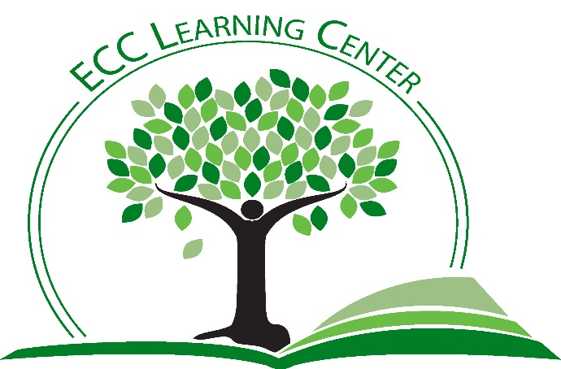
PEER TUTOR APPLICATION
The Learning Center
Thank you for your interest in becoming a peer tutor.
Below is an explanation of the requirements for the peer tutor position and the process required for consideration as a peer tutor.

Please return the completed application to Jon Thrower
Associate Director of The Learning Center
BH 189

Requirements:
- Tutors must have and maintain a 3.0 or higher GPA.
- Tutors must have taken each course they wish to tutor, with the exception of tutoring in a course below the highest level of course completed by the tutor.
- Tutors must have received an “A” or “B” in the subject which they wish to tutor.
- Tutors must have 3 faculty recommendations, with at least 1 from a previous instructor in the specific subject they intend to tutor.
- All potential tutors must fill out a Student Worker application and FAFSA in Human Resources.
- All potential tutors must be enrolled in courses full-time (excepting summer employment).

Expectations:
- Tutors will attend and participate in a Peer Tutoring course throughout the semester. This course is designed to meet the criteria for CRLA certification. The course is set-up and taught by the Director and Assistant Director of The Learning Center.
- Tutors must consistently log tutoring sessions into TutorTrac.
- Tutors are to maintain current, up-to-date knowledge of subject material(s).
- Tutors must keep the Associate Director apprised of schedule changes.
- Tutors must respect confidentiality of tutoring sessions and follow FERPA guidelines.
- Tutors must communicate effectively with peers, co-workers, TLC Specialists, Associate Director, and Director of The Learning Center.
- Tutors must be mindful of TLC policies and procedures and follow rules dictated by The Learning Center Policy and Procedure manual.
- Tutors must be mindful and respectful of all ECC staff and student population and follow the ECC Code of Conduct.

Benefits:
- Tutors gain excellent professional experience for future positions.
- Tutoring is a paid campus employment position, at a rate of $7.35/hour.
- Tutors set their own schedule in consultation with the Associate Director of TLC.
- Tutors earn satisfaction in helping other students develop skills and knowledge for academic success.
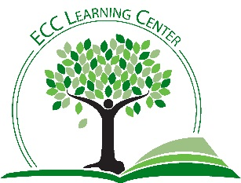
PEER TUTOR APPLICATION
The Learning Center
East Central College

Name: ________________________________________________________ Student ID#_________________________

Phone: ______-_________-__________ Email ________________________________________________________

Address: _____________________________________________________________________________________________

Major: ______________________________ GPA________ Credit hours currently enrolled in __________

Do you plan to graduate from ECC? ________ Expected date of graduation: _______________________

Subject(s) you wish to tutor: Check the subject box(es) you wish to tutor. Then circle all courses in that subject you can tutor.

MATH Pre-Algebra Intro. Algebra Interm. Algebra College Algebra

Pre-Calc. Calc I Calc II Calc III Business Math

ENGLISH Intro to Writing Comp I Comp II Other:___________________________

CHEMISTRY Fundamentals Intro Gen Organic

BIOLOGY Nutrition Intro to Life Science Gen Bio Prin Bio

Intro A&P A&PI A&P II Micro

COMPUTERS Word Excel PowerPoint Access

OTHER: _________________________________________________________________
You will be contacted for an interview when all paperwork has been received and reviewed. Student workers are hired based on need/subject and budget availability. Approved work hours are dictated by Financial Aid, with the maximum of 19.75 hours per week. You cannot begin work until approved by HR, Financial Aid, and TLC. Please direct all questions to Jon Thrower, Associate Director, The Learning Center at jon.thrower@eastcentral.edu or 636-584-6595.

