**Contemporary Math Review Guide**

**Chapters 1 and 2**

1. , therefore  is an example of inductive or deductive reasoning?
2. Practice makes perfect. Therefore, if I practice, I’ll be perfect. Inductive or deductive reasoning?
3. Fresh fruit costs more in winter. This is January. These fresh strawberries cost more. Inductive or deductive reasoning?
4. Use inductive reasoning to predict the next term in the sequence of numbers. 2, 5, 4, 10, 8, 20,?
5. How many different squares are there in an 8 by 8 square? Use inductive reasoning to answer.
6. Illustrate Goldbach’s conjecture for the following number. 36
7. Illustrate Goldbach’s conjecture for the following number. 48
8. Continue the pattern for five more items in the list. 180, 169, 158, 147, …
9. Continue the pattern for five more items in the list. aaa, aab, aba, …

**Determine whether the statement is true of false. If it is true, give two examples to illustrate it. If it is false, give a single counterexample.**

1. If you make the sides of as square 6 times longer, the area of the square is 36 times larger.
2. If Alex got a higher grade than Ethan, and Harrison got a lower grade than Ethan, then Harrison got a lower grade than Alex.

**For #12-13, decide wither the two sequences of operations give the same result.**

1. Adding $m$ and $n$ and then multiplying the sum by 7

Multiplying $m$ by 7, multiplying $n$ by 7, and then adding the two products.

1. Dividing r by 5, then dividing s by 6, then multiplying the quotients

Multiplying r and s, then dividing by 5

**In a school survey, students showed these preferences for instructional materials.**

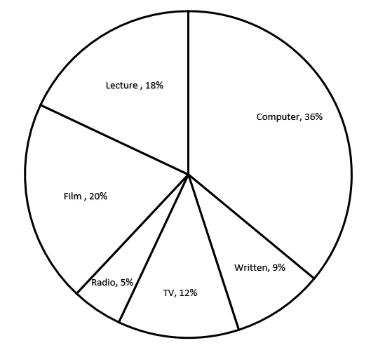

1. About how many students would you expect to prefer lectures in a school of 950 students?
2. 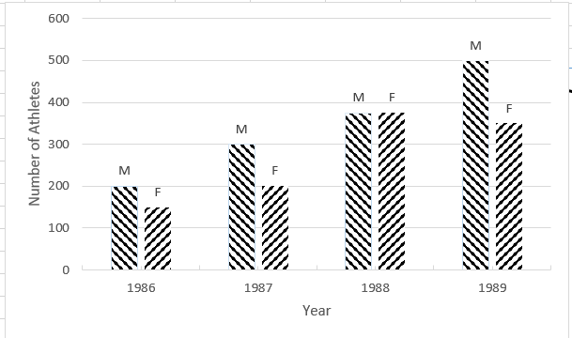Refer to the double bar graph below which shows the number of male (M) and female (F) athletes at a university over a four-year period. In which year was the number of male athletes equal to 375?
3. Estimate the answer by rounding to the nearest hundred. 
4. Estimate by rounding to the nearest ten. 
5. Use set notation to list all of the elements of the set of the integers from 3 to 7 inclusive.
6. Use set notation to list all of the elements of the set of 
7. Use set notation to list all of the elements of the set of the whole numbers between -3 and 0, not inclusive.
8. Use an alternative method to express the set of 
9. Find  for the set 
10. Find  for the set 
11. Find for the set 
12. Is the set of even numbers greater than 100 a finite set or an infinite set?
13. Is the set finite or infinite?
14. Decide whether the sets are equal.

and 

1. Decide whether the sets are equal.



1. Decide whether the sets are equivalent.



1. Decide whether the sets are equivalent.



1. List all the two element subsets of the set 

**Use the following definitions to determine if the statements in #34-35 are true or false.**



1. W is a subset of N, W, I, Q, and R.
2. W is a proper subset of I, Q, and R.
3. Find the number of subsets in the set 
4. Find the number of subsets in the set 
5. Find the number of subsets in the set 

**Use the following sets to answer #39-42**



1. List the elements in the set 
2. List the elements in the set 
3. List the elements in the set 
4. List the elements in the set 
5. Shade the Venn diagram to represent the set 
6. Shade the Venn Diagram to represent 
7. Shade the Venn Diagram to represent 

**U**

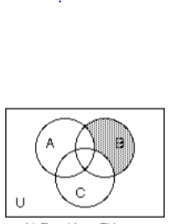**For #44-46, write a description of the shaded region using the symbols as needed.**

1. 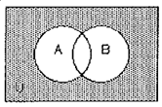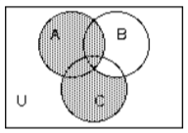 **45.** **46.**

**Use the Venn diagram below for exercises 47-48. Find the number of elements in the regions.**

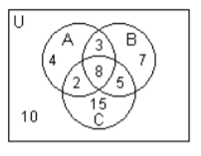

1. 
2. 
3. Find, if possible, the number of elements in sets *A*, *B*, and *C* using the given information.



1. Solve the problem: A survey of 240 families showed that 91 had a dog, 70 had a cat, 31 and a dog and a cat; 91 had neither a cat nor a dog nor a parakeet; 7 had a cat, a dog, and a parakeet. How many had a parakeet only?

**Chapters 3, 6, & 7**

1. Write the statement in symbolic form: If you exercise, then you will feel great or you will sleep better.
2. Use the following definitions to translate the statement into words.

*p*: The monitor is included.

*q*: The color printer is optional.

*r*: The zip drive is extra.

1. Negate the quantified statement, “All squares are parallelograms,” and rewrite it in English in an alternative way.
2. Construct a truth table for the compound statement: 
3. Determine whether the statements are logically equivalent.



1. Construct a truth table for the statement: 
2. Write, the contrapositive for the statement, “If you received a refund of over $1,000, then you cannot make a claim.”
3. Given: *If the pond contains algae, then the pond does not contain trout.*

*If the pond does not contain algae and does not contain trout, then the pond does not contain frogs.*

Determine whether the argument is valid or invalid:

The pond contains algae.

Therefore, the pond contains frogs.

1. For the arithmetic sequence, -10, -6, -2, 2, ... , find 
2. For the geometric sequence, 3, -9, 27, -81,… find .
3. Solve the equation : 
4. Solve the equation  for 
5. Find the slope of the line passing through the points (-6, -7) and (-2,8).
6. What is the slope and y-intercept of the graph of the equation 
7. The cost of a tourist package depends on the number of sightseeing stops that you have. The ordered pair (2, 170) means that 2 stops cost $170, and the ordered pair (6, 310) means that 6 stops cost $310.

Write a linear equation giving the cost, y, in terms of the number of stops x.

Using the equation found in part a, find how much it costs for 3 stops.

How many stops would there be if the cost is $415?

1. College students can purchase points for use in the food service areas instead of cash. If you initially pay the basic food service fee of $45, then points can be purchased for 30 cents each; otherwise, points cost 60 cents each. How many points must you use in order for it to be cheaper to pay the basic food service fee?
2. Find the slope intercept equation of the line that has slope 5 and passes through the point (-3, 7)
3. Find the slope intercept equation of the line that passes through the points (-8, 0) and (9, -6).
4. Suppose that a sales person observes that if an item is priced at $7 per item then 5 items are sold. If 3 items are sold for $9 per item then find an equation to model the number y of items sold for x dollars per item.
5. Solve the quadratic equation: 
6. Find the vertex of the quadratic equation  and determine whether the graph opens up or down.
7. Find the x-intercepts and y intercept of the quadratic equation 
8. 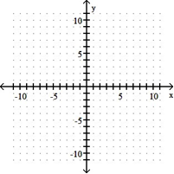Graph 
9. If a county has a population of 988 million in 2000 and a constant growth rate of 1.5 percent per year, then what will the population of that county be in 2012?
10. John Lee's savings account has a balance of $ 1509. After 9 years, what will the amount of interest be at 6% compounded annually? Round to the nearest dollar.
11. Find the arc length of the arc AB if the central angle ACB of a circle of circumference 8 meters has a measure of 80o.
12. Find a pair of obtuse, alternate exterior angles:

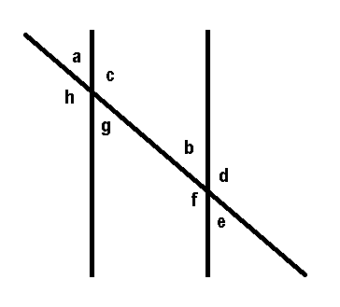

1. What is the measure of each angle in a regular octagon?
2. A polygon has sides of length 3, 5, 7, and 9. What is the length of the shortest side of a similar polygon whose second longest side has length 12?
3. Find the area of a trapezoid with height 5ft and whose bases total 18 feet.
4. Find the area inside the circle but outside the square:

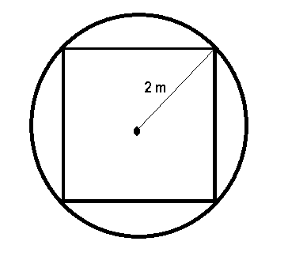

1. How much more liquid does a cylindrical tank with radius 3 feet and height 12 feet hold than a similar tank with radius 2 feet and height 10 feet?
2. A smaller than average beach ball has a volume of 36 in3, what is its radius?
3. Find the volume of a can in m3 if its diameter is 20 cm and its height is 30 cm.
4. Express the rate 10 ft/sec in miles/hr.
5. A student ID code must start with a letter that can be capital or lowercase and end in four digits that could be repeated. How many possible ID codes are there?
6. Frank, Fred, Mark, and Mike are sitting together in a row. How many fewer arrangements are there if Mark and Mike must be in the middle seats than if they can be in any order?
7. A model of car is available in exterior colors of indigo, midnight, titanium, slate, and frost. Interior color options are beige, granite, moonlight, and pewter. How many options of color combinations are there if slate is not available with beige?
8. A multiple choice test has 6 questions. How many more keys are possible if each question has five choices instead of four choices?
9. How many ways can the books “Algebra”, “Booleans”, “Contemporary”, “Differentials”, “Euler’s Methods”, “Fermat’s Work”, and “Great Mathematicians” be arranged on a shelf?

**Chapter 13 (Sections 1-4)**

1. If the probability than an identified hurricane will make a direct hit on a certain stretch of beach is , what are the odds against a direct hit?
2. If two fair dice are rolled, what is the probability that a total of four shows?
3. The odds against Carl beating his friend in a round of golf are 9:7. Find the probability that Carl will lose.
4. If , find .
5. If , find .
6. If a single card is drawn from a standard 52 card deck, what is the probability that it is neither a Jack nor a club?
7. For a school project, Sue interviewed a total of 100 persons with were either lawyers or salesmen. She asked them if they were happy or unhappy with their occupation. Of the 59 lawyers she interviewed, 14 were unhappy, however, only 9 of the salesmen were unhappy. Supposed that one of the persons interviewed is selected at random. Find the probability that the person selected is happy.
8. A box contains 24 blue marbles, 13 green marbles, and 13 red marbles. Two marbles are selected at random without replacement. Let E be the event that the first marble selected is green. Let F be the event that the second marble selected is green. Find .
9. A survey of senior citizens at a doctor’s office shows that 52% of the seniors take blood pressure lowering medication and 40% take cholesterol lowering medication. 17% take both medications. What is the probability that a senior citizen takes only one of these medications given that he or she takes at least one of the medications?
10. A pair of fair dice are rolled. Let E be the event that the sum is less than ten. Let F be the event that at least one die shows a six. Are E and F dependent events?
11. We roll a pair of dice. If the sum of the dice is 7, you pay me $33. If the sum is not 7, I pay you the number of dollars indicated by the sum of the dice. What is your expected value for the game?
12. You are playing a game in which a single die is rolled. If a 2 or a 5 comes up, you win $48, otherwise, you lose $36. What is your expected value for the game?
13. A student is taking a standardized test consisting of multiple choice questions for which there are five options for each question. Seven points are awarded for each correct answer, but the student loses 2 points for an incorrect answer. Questions left blank receive zero points, but no points are deducted. Is it in the student’s best interest to guess?
14. Keven asked some of his friends how many hours they worked during the previous week at their after-school jobs. The results are shown below. Construct a table showing the frequency and the relative frequency of the hours worked at after-school jobs.

6 5 6 3 6 6 9 8 6 4 8 5 5 8 6 5 8 6 5 8 5 8 8 3

1. A major league baseball player got the following number of hits during each year of his career:  
   55, 112, 183, 177, 184, 188, 190, 178, 158, 167, 151, 142, 116, 40.   
   What is the mode of the data?
2. Find the mean, median, and mode for the given distribution.

11, 9, 7, 5, 12, 11, 11, 9, 5, 12, 11, 7, 15, 5, 11, 11, 7, 9, 5, 11

1. The test scores of 32 students are listed below. What are the minimum value, Q1, median, Q3, and the maximum value? 32 37 41 44 46 48 53 55 57 57 59 63 65 66 68 69 70 71 74 74 75 77 78 79 81 82 83 86 89 92 95 99
2. The following are the ages of 17 people at their 50-year college reunion:

|  |  |  |  |  |  |  |
| --- | --- | --- | --- | --- | --- | --- |
| Score | 69 | 71 | 72 | 73 | 76 | 79 |
| Frequency | 2 | 7 | 4 | 2 | 1 | 1 |

What is the mean and standard deviation?

1. Assume that the following table gives the price (in dollars) of a loaf of bread and a gallon of milk over the first six months of the year. Use the coefficient of variation to determine if bread prices or milk prices were more stable over that time period.

|  |  |  |
| --- | --- | --- |
|  | Bread | Milk |
| Jan | 2.42 | 1.55 |
| Feb | 2.49 | 1.66 |
| Mar | 2.55 | 1.78 |
| Apr | 2.72 | 1.78 |
| May | 2.66 | 1.65 |
| Jun | 2.60 | 1.65 |

1. Suppose that for a given month that the mean daily closing price (all numbers in dollars) for Expensive, Inc. common stock was 122.6 with a standard deviation of 15.9. For Cheap, Inc. stock, the mean daily closing price was 61.8 with a standard deviation of 6.2. Which stock was more volatile (i.e., had a greater coefficient of variation)?
2. Find the standard deviation. Round to one more place than the data.

166 111 135 130 152 274 185 290 245

**Contemporary Math Review Guide Answers**

1. Deductive
2. Deductive
3. Deductive
4. 16
5. 204
6. 7+29
7. 17+31
8. 136,125, 114, 103, 92
9. baa, abb, bab, bba, bbb
10. True
11. True
12. Yes
13. No
14. About 171 students
15. 1988
16. 2900
17. 230
18. 
19. 
20. 
21. 
22. 
23. 
24. 
25. Infinite
26. Finite
27. No
28. No
29. No
30. Yes
31. 
32. False
33. True
34. 16
35. 32
36. 8
37. 
38. 
39. 
40. 
41. 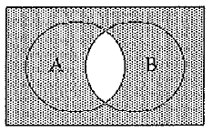
42. 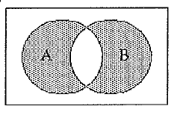
43. 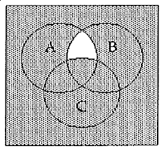
44. 
45. 
46. 
47. 24
48. 8
49. 
50. 19
51. 
52. The monitor is not included and the zip drive is not extra
53. Some squares are not parallelograms.

|  |  |  |  |
| --- | --- | --- | --- |
| *p* | *s* | *c* |  |
| T | T | T | T |
| T | T | F | T |
| T | F | T | T |
| T | F | F | T |
| F | T | T | F |
| F | T | F | T |
| F | F | T | T |
| F | F | F | T |

1. Equivalent

|  |  |  |
| --- | --- | --- |
| *s* | *q* |  |
| T | T | T |
| T | F | T |
| F | T | T |
| F | F | F |

1. If you made a claim, then you cannot receive a refund of over $1000.
2. Invalid
3. - 38
4. - 2187
5. 
6. 
7. 
8. 
9. a. 

b. $205

c. 9 stops

1. 150 points
2. 
3. 
4. 
5. 
6. , opens up
7. x-intercepts: 

y-intercept: 

1. 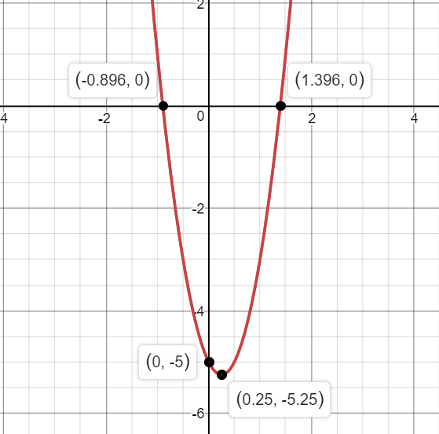
2. 1,181.3 million
3. $2549
4. 
5. d and h
6. 
7. 
8. 45 ft
9. ≈ 4.56 m2
10. ≈ 213.52 ft3
11. 3 in
12. ≈ 0.00942 m3
13. 6.82 mi/hr
14. 52,000
15. 20
16. 19
17. 11529
18. 5040
19. 99 to 1
20. 
21. 
22. 0.16
23. 0.42
24. 
25. 0.77
26. 
27. 0.77
28. Yes
29. $0.33
30. -$8
31. No
32. 
33. None
34. Median: 10

Mean: 9.2

Mode: 11

1. 32, 56, 69.5, 80 ,99
2. Mean: 71.9

Standard Deviation: 2.46

1. Bread was more stable
2. Expensive, Inc.
3. Standard Deviation: 66.1