Student Printing

BALANCE CHECK

To Log on and check your balance of printing: Username and Password

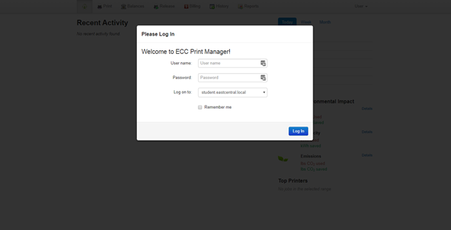

Once you are log on you will see your home page and check your balance: 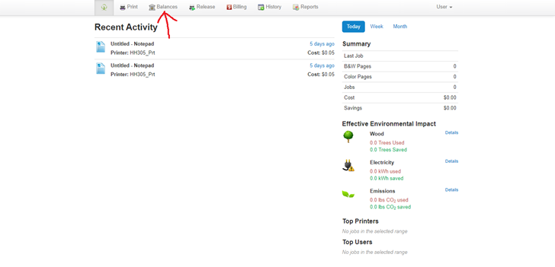

It will show your primary balance and paid balances. Primary is the free printing you get each semester. Once the primary is depleted you will need to go to the cashier or library to add to your paid account.

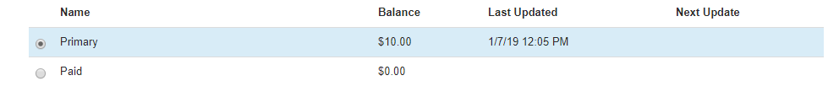

WI-FI PRINTING

Students can now Wifi print to printers in the Learning Center and Library. Once logged in to print.eastcentral.edu from your laptop you can go to the print selection at the top and then install the web printer software on your laptop. Then choose the location of the file and upload it. Select the file and hit next.

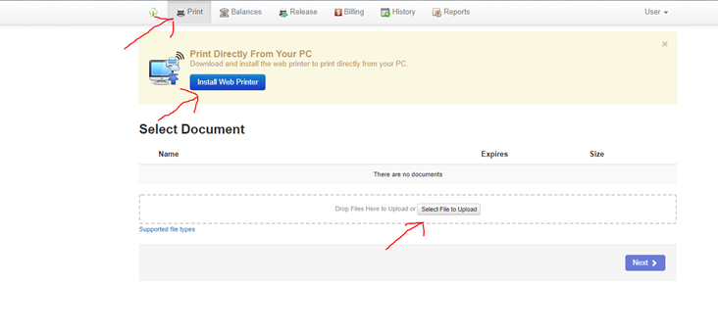

You will then select the appropriate printer you want to print to and print the job.

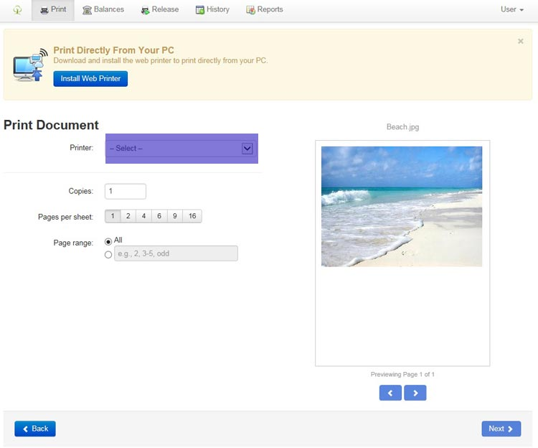

Select the printer you would like to print to by clicking on the dropdown arrow

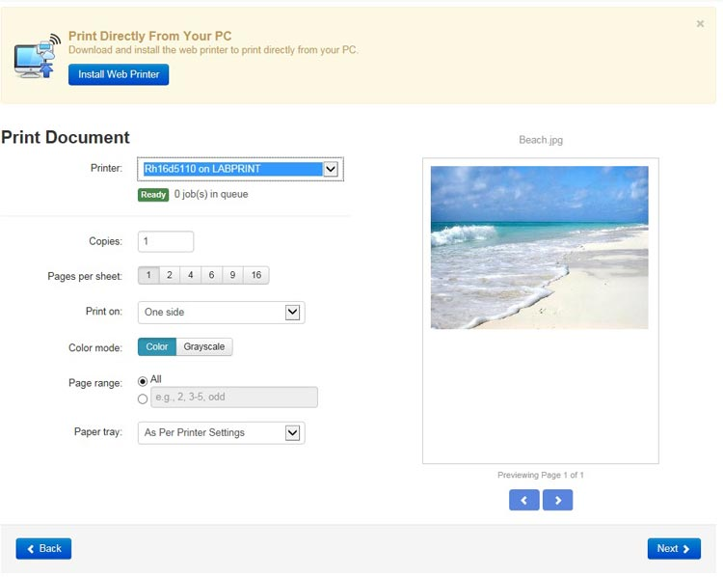

Click the "NEXT" button in the lower right of the screen to send the file to the selected printer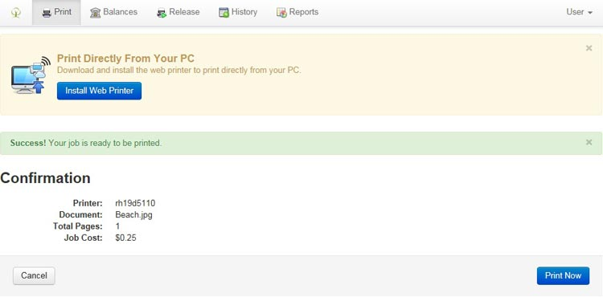

The above confirmation will appear and ask if you are sure you want to print the document. If you are sure you want to print, click on the "PRINT NOW" button to release the job to the selected printer. You will receive this confirmation screen to let you know your job was released to the printer.

