Advising Survey Report for the Spring 2014 Registration Period

Introduction

To evaluate the effectiveness of academic advising at East Central College, the Advisement Department conducted a survey during the Spring 2014 registration period. The feedback was intended to measure what students thought about their experience when meeting with advisors to enroll in classes.

All students who registered for Spring 2014 regular classes (i.e. non-Dual Credit and non-Dual Tech Credit) were emailed through their FalconMail accounts and asked to participate in a brief online survey about the advisement and enrollment experience. The survey was done anonymously through surveymonkey.com. Of the approximate 3050 students who enrolled at East Central College, 371 responded with at least some feedback. This represents about 12% of the total ECC student population.

The survey questions were culled from the Advising Syllabus. In addition to asking what core advising resource was used, the students were asked binary questions directly related to the “What Is Expected of Advisors” section of the syllabus. The purpose of the survey was to do an initial overview of how students perceive the academic advising process at East Central College. Students also were given the opportunity to leave a narrative comment regarding their experience.

Recommendations

The survey was intended as an initial inquiry to ‘measure the temperature’ of how students consider the ECC advising process. While the surface outcomes look very favorable, it is recommended that additional surveys and perhaps focus groups be conducted to identify what advisors do well and which advising tendencies have negative effects on students. These can be done within a ‘continuous improvement’ model and may be appropriate as an AQIP project.

Based on the narrative comments, it is recommended that all ECC employees in the advisement process be trained in customer service techniques that improve the overall enrollment experience. While the negative feedback was proportionally small, the narrative comments indicate improvement is warranted. Increased positive customer service may have a significant effect on students’ perceptions of the advisement process and East Central College as a whole.

Brief Analysis

Overall, students report high satisfaction based on the measurements of this survey. Using the percentages on the responses, ECC advising, both General Advisors and Faculty Members, earned an “A” for this registration period.

The number of students who use General Advisors is high. When considering that the Students Service Center exclusively uses General Advisors and the Rolla and Sullivan sites primarily use General Advisors, 65.6% of ECC students who responded to this survey used a General Advisor resource to enroll for Spring 2014. (Note: The question asks for “all that apply,” resulting in an inflated total percentage response of 107.3%)

Students want more choices and options. Although 86.7% of responding students said that they were presented choices and options for their academic program, it is noteworthy that this was lower than all but one of the other measures. Presenting greater variety for students (more available class times, greater variety of classes, Fact Sheets which allow for increased flexibility to satisfy degree requirements, etc.) may assist in students being more satisfied with the advisement process.

Students want to feel valued. This observation is based on the narrative comments from students. Students who perceive that they are important and respected tended to report higher satisfaction with the advisement process. (see the “Narrative Responses” summaries for more detail)

The Advising Syllabus is underused. Ironically, what scored lowest in the survey was the students’ awareness of the Advising Syllabus. 43.1% of students who responded stated they were not familiar with it. The Advising Syllabus is presented to all incoming students via a New Student Folder and it is available online under the Advising Resources webpage tab. All advisors should be encouraged to use this tool as a reference.

Response Summary

To register for the 2014 Spring Semester, did you access an advisor in the Student Service Center on main campus, use the Rolla or Sullivan or Washington site, or visit an assigned faculty member?
Raw Number %
Student Service Center on main campus 169 47.6
Rolla or Sullivan sites 64 18.0
Washington site 10 2.8
Faculty member 138 38.9

Was the academic advisor available at a time which was convenient for you?
Raw Number %
Yes 347 94.3
No 21 5.7

Was the academic advisor considerate of your interests and career choices?
Raw Number %
Yes 351 95.4
No 17 4.6

Did the academic advisor effectively communicate the requirements for your program?
Raw Number %
Yes 336 91.3
No 32 8.7

Did the academic advisor present choices and options for your program?
Raw Number %
Yes 319 86.7
No 49 13.3

Did the advisor understand your academic goals?
Raw Number %
Yes 351 95.6
No 16 4.4

Are you familiar with the East Central College Advising Syllabus?
Raw Number %
Yes 209 56.9
No 158 43.1

Visual representation indicating where students registered for Spring 2014

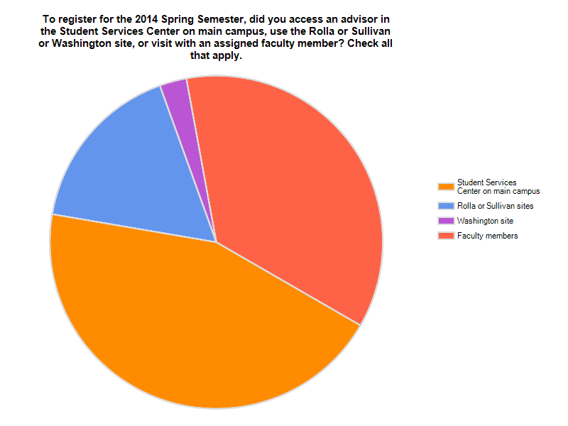

At the end of the survey, students were given the opportunity to leave a narrative response with the prompt, “Please give us some feedback regarding your experience registering for the 2014 Spring Semester at East Central College.”

Negative Narrative Responses Summary

The narrative responses which could be categorized as ‘negative’ tended to be longer and more detailed than the positive comments. Of the 230 narrative comments submitted by student respondents, 36 (15.7%) were undeniably negative.

A common theme among these responses were written with emotional language, with some explicitly using the verb “feel” to help convey their impression of the advising process.

Below are samples of the comments which were negative. Names were removed and replaced with either “Faculty Member” or “General Advisor.”

Negative Narrative Responses Samples

I didn’t get a lot of helpful information from my meeting with the advisor. I was scheduled with a general advisor since I'm transferring after completing my gen. ed.

Thought the advisor was rude and made me feel stupid.

I wish there was more of a choice in what classes. I felt like they were being chosen for me. Also, I just registered and didn't get to talk to my advisor

My actual advisor did very little in enrolling me in my core classes I needed. I went to the head of the department for my degree to get enrolled for my core classes because my actual advisor would not email me back and was not in his office when he was supposed to be. I finally got in with him Tuesday to register for my last two electives for the next semester, but I feel slightly discarded and blown off. I had to go to his boss to get a meeting with him, that's slightly ridiculous.

My student adviser was available but went off on some kind of fun run-around. And so instead I met with an adviser that was available and he was very helpful and understanding of what I figured I wanted and needed to take for my general studies degree.

[Faculty Member] spoke too fast and was in a hurry to get me scheduled, she overlapped my classes by accident which caused me to take off work to figure everything, making me running around campus to find a math instructor to sign that I am allowed to leave their class 10 minutes early. Which they have not scheduled math teachers to classes yet, so if my instructor does not allow me to leave early I have to reschedule and drop Biology for History. I hate History, and I love Biology. If I have to do so I'll be very disappointed in how unorganized ECC has been this semester.

I have found it less stressful and aggravating to go to the student service center to register for classes rather than my assigned faculty advisor.

Many people who helped me didn't guide me through the final online registration which was rather confusing. I tried five times on my own using the step-by-step worksheet, but that still didn't work. I finally had to have a general advisor help me. I wish my academic advisor would have completed the online part for me or showed me on the computer, so I knew how to do it next time. Other than that, I had a simple experience registering.

I would have liked the degree requirements to have been laid out correctly when I signed up for classes last semester. I was under the impression that there would be a few more classes available in the Spring that aren't actually offered.

It was ok. I wish there was a more easily understandable guide to look at to see what I need to complete my degree program. I would rather not have to talk to an advisor every time I have a question about what my next step might be.

[Faculty Member] was rude to me, did not explain things well, and did not care about my academic goals and choices. She disregarded many things I said. I was more than frustrated leaving the appointment and considered switching colleges.

When I meet with my advisors I just don’t want to feel rushed. It feels like sometimes they are in a hurry to get you out the door. I also don’t want to feel pressured in any way.

New faculty members should not be able to do advising. The one I met with had to double check everything. What should have been a 10 minute appointment turned into 35 minutes.

My advisor helped me sign up for classes. What I found irritating is that East Central website offers students the option to sign up online, but students aren't actually able to use this feature. I know what classes I want to sign up for and what classes I need. I should be able to sign up for classes myself and the advisor approve them. I had no issues with my advisor. I had issues with a useless feature on East Central website.

My assigned advisor was new and not very helpful at all so that's when I went to the main desk.

[Faculty Member] seemed to be unaware of what I needed to do to complete my graduation requirements. I felt like I knew more than she did and came in the meeting knowing what classes I had to take based on program evaluation and degree plans. She didn't know what all I needed to take and was supposed to call me when she found on information about a class and never did.

It went well, but I felt like I was somewhat of a bother to the advisor.

I had a lot of trouble coming up with a time to meet with my advisor, [Faculty Member]. When I finally did meet with him, he really did not help me with the registering process at all. He didn't even turn on his computer once to help me look up classes. When it came to registering, he had me go get a form, and he simply signed it and sent me on my way. I had to make another appointment with someone at the help center because I was so clueless to the registering process.

The first advisor I talked with was kind of rude and impatient with me and advised me to register online even though I told her I would rather do it in person so I don't mess anything up. I left and came a different day and the second advisor helped me greatly.

I did not get to actually talk to my advisor even though I emailed her to ask her for a meeting and she said yes. It was somewhat frustrating.

I had to visit the student center for an advisor because my assigned advisor [Faculty Member] did not know what she was doing and couldn't help me at all. Ex. She didn't know how to allow me to register online, and didn't know what classes or how many of humanities, sciences, etc. that I needed.

Positive Narrative Responses Summary

As with the rest of the survey, the majority of the narrative responses were primarily positive. These comments tended to contain no referential information. Many of the positive responses were casual and succinct, such as, “It’s all good,” “Everything went smooth,” and, “Easy peasy lemon squeezy.”

This category of responses also had a high degree of positive emotional language. The following are samples of the positive comments received. Names were removed and replaced with either “Faculty Member” or “General Advisor.”

Positive Narrative Responses Samples

It’s been great. Hoping this helps me transfer later smoothly to MS&T. You guys have been extremely helpful so far.

I really enjoyed my time with [General Advisor]. She made me feel comfortable during my process.

ECC is one of the very best colleges I have experienced regarding timely, and considerate registration.

Advisor showed hospitality and did her job very well.

My advisor [Faculty Member] is always very polite and extremely patient and helpful when I am registering for classes. I have never had any problems with any other faculty either when searching for answers that she cannot answer.

I really enjoyed talking with my adviser, she was very helpful. I only went to student services because there was a class I was unsure how to register for.

[Faculty Member] is my advisor and she did a very good job at helping me pick classes and making sure I knew how to use the internet registration before just leaving me on my own.

[General Advisor] has always been very helpful and supportive with my class choices. When asked why I was taking two physical education classes since I don't need them, she understood that stress relief and fitness were important to me, especially during school.

My advisor helped me understand the whole concept of registration and helped me effectively prepare for the Spring 2014 semester.

The adviser I used was friendly and caring. He asked me good questions to determine the best classes for me to take that fit both my degree and my personal preferences.

It was all quite painless, and my advisor was very helpful, going over each future semester to help me plan ahead. She made suggestions, but also listened to my concerns.

My advisor was very helpful and she encourages me to come to her with any problems that I have.

Loved my advisor. Very friendly. Helped me make a schedule that fit my wants and needs. Went back next day because I had questions. She answered them all fully and accurately.

My advisor put my interests first, and knowing I was going for a bachelor’s degree suggested I get some classes out of the way now that I'll need later.

[General Advisor] is awesome!! She was so kind, and seemed to truly care about my future.

