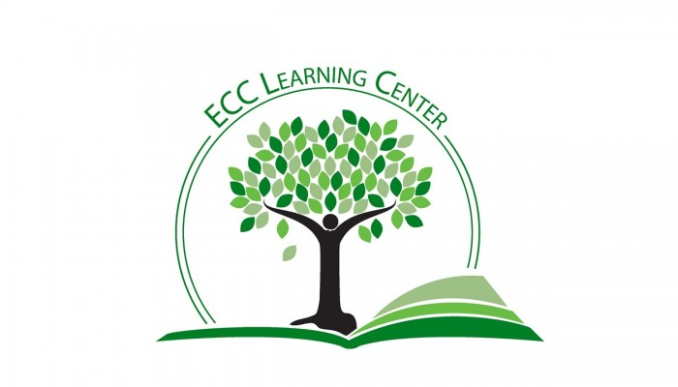
Self-Editing Checklist for College Papers
Introduction
☐Title
You should have an interesting, meaningful title that captures the reader’s attention. Don’t simply name the assignment (i.e., Argument Essay).
☐Hook
The opening sentence(s) of your paper should grab the reader’s interest and make them want to read more. Possibilities:
- Brief story that illustrates your main idea (HINT: be sure you can connect this to your thesis in a meaningful way)
- Concrete example
- Surprising fact
☐Thesis
A strong thesis statement will provide a clear outline for the whole paper. Keep in mind:
- The thesis should match the assignment. A thesis for a compare-contrast paper will be different from a thesis for a research paper or a persuasive paper.
- A thesis should never be written as a question.
- A thesis statement is often placed at the end of the introductory paragraph.
- A strong thesis statement will often forecast the main points to be covered in the paper.
- A separate forecast statement also can work well.
Body Paragraphs
☐Does each paragraph have a topic sentence that clearly summarizes all of the points in that paragraph?
☐Does each topic sentence clearly relate back to the thesis statement?
☐Does all of the information in the paragraph relate to the topic sentence?
☐Are the body paragraphs in the same order as the topics in your thesis/forecast statement?
☐Does the concluding sentence in each provide a transition to the next paragraph?
Editing the Text
☐Have you removed unnecessary words, especially adverbs (very, really…)?
☐Have you used a varied vocabulary? Use a thesaurus or dictionary to find replacements for repeated words.
☐Are your sentences varied in terms of length and structure? A mixture of long and short sentences is best.
☐Are all of your transitions smooth and clear?
☐Are your verb tenses consistent? Do they match your discipline? (History=past; Literature=present)
☐Are you using strong, interesting verbs? (“hurried to the store” is more interesting than “went to the store”).
☐Are you using active voice rather than passive voice? Examples:
- Active voice: Andrew bought the book.
- Passive voice: The book was bought by Andrew.
☐Have you read your paper out loud to catch errors that are hard to find? (This really is one of the best ways to revise your writing.)
Formatting
☐Did you make sure the margins, page numbers, headings, line spacing, & etc… meet the formatting style the instructor requires? HINT: The Purdue OWL (Online Writing Lab) website provides helpful guidelines for most formatting styles, including:
- MLA (English & Humanities)
- APA (Social Sciences)
- Chicago Manual of Style (History)
☐Margins
☐Page numbers
☐Heading(s)/Cover Page
☐References/Works Cited/Bibiography Page
Integration of Sources
☐Have you placed a citation after EVERY use of source material?
☐Concepts/Ideas: Even if they are described in your own words, concepts and ideas derived from sources should be cited.
☐Summaries
☐Paraphrases
☐Quotations
☐Are all of your quotations introduced and explained properly?
Grammar and Mechanics
☐Have you checked your paper for spelling errors?
☐Have you looked for common punctuation problems, such as comma usage?
☐Is your paper free of fragments and run-ons?
The Learning Center
☐Have you considered making an appointment with an English Specialist in the Learning Center? We can help!
☐Have you considered using the Online Writing Center? You typically will receive comments within 24 hours.

