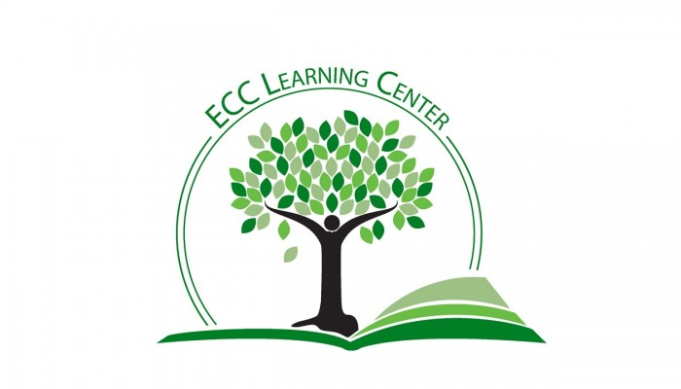
PROOFREADING
Have you ever proofread a paper multiple times, only to have the instructor hand it back with the comment that you need to proofread better? That can be incredibly frustrating. It’s difficult to proofread something that you have written because your brain tends to focus on the overall meaning, skimming over the line-level errors you need to fix.
How can you solve this common problem? Here are three strategies for better proofreading:
- Read Backwards
- Read Aloud
- Read with a Pencil
READ BACKWARDS
Reading backwards allows you to take each sentence out of context, so that errors and awkward phrases stand out. For this strategy, you read the last sentence, then the second-to-last sentence, then the third-to-last sentence, and so on, all the way back to the start of your essay.
READ OUT LOUD
It may feel a little strange, but reading out loud is an excellent way to catch errors. When you hear a sentence that doesn’t sound right, it will stand out. If you find that you stumble over certain words, it’s a good indication that you may need to revise there. For this technique to be most effective, you have to read slowly and listen carefully. You might also combine this technique with the previous one and read your paper backwards out loud.
READ WITH A PENCIL
As you read your paper aloud, follow along with a pencil moving under each word as you say it. This can help you to catch errors, awkward phrases, or places where you left out words.

