Writer’s Block
Do you ever feel discouraged when you start a new writing assignment because you have no idea what to say? You may have no ideas, struggle with too many ideas, or dislike your ideas. This is happens all the time and is called writer’s block. Writer’s block is the result of anxiety caused by your inner critic who expects perfection on the first draft. The key to beating writer’s block is getting past that critical inner voice.
Strategies to Battle Writer’s Block
- Freewrite: Write for ten minutes without stopping, just to get some ideas flowing. Don’t worry about grammar, punctuation, or anything else. Just keep writing.
- Cluster: Graphically cluster ideas, subtopics, and details. Here is an example: 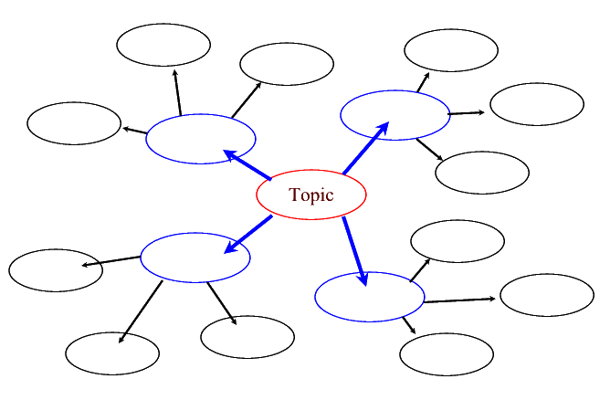
- Journal: Write journal entries about your assignment, its purpose, how you feel about it, and any ideas you may have, even if you don’t like them.
- Talk It Out: Talk about ideas you have on the topic with someone else or into a recorder. Ask yourself or have someone else ask you questions about your topic. Often, you will say something unexpected, and it will be the beginning of a thesis for your paper.
- Begin In the Middle: If you know something you want to say, write a body paragraph first, just to get started. One idea may lead to another. You can always write the introduction last.
- Create a specified time to write: Show up and start writing at a certain time every day to develop a routine.
- Try the Pomodoro technique:
  - Pick a time to start your paper.
  - Set a timer for 25 minutes and start writing
  - When the time rings, take a 5 minute break
  - Repeat steps 2-3
  - Every four cycles, take a 25 minute break.
- Visit the Learning Center: Meet with a writing specialist to brainstorm about a topic that will both interest you and fit the assignment.

