Time/Day of Week | Monday  DAY ONE | Tuesday  DAY TWO | Wednesday  DAY THREE | Thursday  DAY FOUR | Friday  DAY FIVE
9-10 AM | Write summary notes for Ch. 1-3 |  | Write summary notes for Ch. 7-8 |  | Review Summary
10-11 AM | Summarize lecture notes from Jan 24-Feb 18 |  | Summarize lecture notes from Mar 8-Apr 1 |  | notes created  on Days 1-4
11-12 PM |  | Write summary notes for Ch. 4-6 |  | Write summary notes for Ch. 9-10
12-1 |  | Summarize lecture notes from Feb 21-Mar 5 |  | Summarize lecture notes from Apr 4-Apr 28
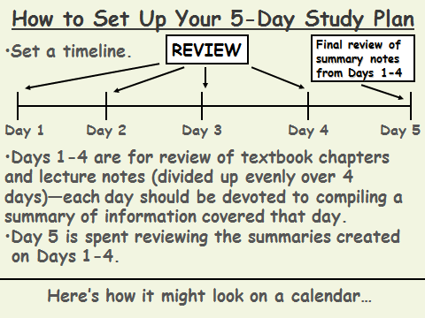
Why do this?
*prevents cramming
*spreads studying over time
*gives your brain time to absorb information
*builds confidence

SAMPLE

5-Day Study Plan for History Course Final:
Covering 10 chapters & all lecture notes!
Most important tool to get ready for EXAMS!!

