Transformations

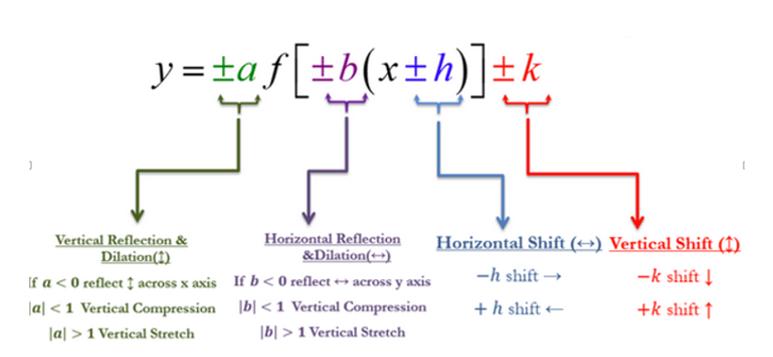

*Mathgotserved.com*