Active and Passive Voice
All sentences can be written in either the active or the passive voice. In the active voice, the subject of the verb performs the action:
The student failed his test.
The student shed many tears.
In the passive voice, the subject receives the verb’s action:
The test was failed by the student.
Many tears were shed by the student.
Notice “by” within the passive voice. A rule of thumb: if you can conclude a sentence with “by pirates,” you’re most likely using the passive voice:
This guide was written by pirates.
The hairdresser was taken to the high seas by pirates.
Here are a few more examples:
Active: The pit-bull bit the man.
Passive: The man was bitten by the pit-bull.
Active: Research shows that smoking leads to statistics.
Passive: That smoking leads to statistics is shown by research.

Try to use the active voice whenever possible. The passive voice often uses too many words, sounds vague, and can lead to a web of prepositional phrases. Also, you can think of the passive voice as the “irresponsible” voice, the voice that doesn’t own up to what it is doing, has done, or will do:
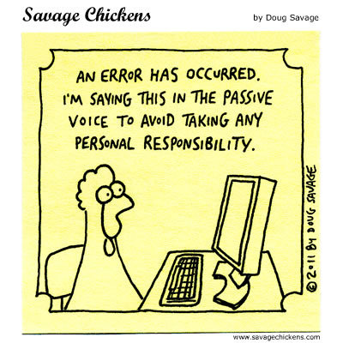

“There is such a thing as the poetry of a mistake, and when you say, "Mistakes were made," you deprive an action of its poetry, and you sound like a weasel.”
― Charles Baxter, Burning Down the House: Essays on Fiction

I couldn’t agree more. Don’t “deprive an action” of its power and use.

(636)584-6688general_tutoring@eastcentral.edu

