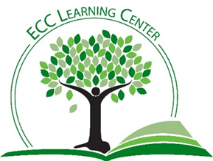
Tips for Writing Your Cover Letter
- Your cover letter will probably be the first thing about you that your potential employer will see. It supplements your resume but does not contain all of its information. The details you provide should be specifically geared toward the recipient.

- Consider using one of the many templates that can be found online.

- The top of your letter should have a header containing correct and up-to-date information about yourself and your potential employer (name, address, email, phone).

- You should address your letter to the specific person who is going to be looking at your resume, preferably by calling them Ms./Mr./Dr. If you do not know their name, then address the letter to the ‘Hiring Manager.’ Do NOT write ‘To whom it may concern.’

- The beginning of your letter should be your personal paragraph in which you communicate your key points.
  - State clearly that you would like to apply for a position, preferably giving the exact name of the position.
  - If you were referred by someone to the job, feel free to mention that person here.
  - Give a brief overview of the skills and experience most relevant to this position.

- In the body paragraph, tell them why you want the job and are the best person for it.
  - Highlight your educational and employment background.
  - Look at the job listing they provided.
  - Discuss your specific qualifications.
  - List your achievements. Have you been promoted? Why? Awards?

- In your conclusion, thank them for the opportunity to be considered for the position.

- Provide a signature line and include your contact information.

- When you are finished, print it out and take a break. Later, come back to it. Proofread it and give it to others to proofread, as well. Stop by the Learning Center and have us take a look! We would be happy to help!

