Student made appointments
Pilot: embedded courses
MTH*094 10 and Web
ENG*90
Students in these classes can make online appointments using tutortrac for all ENG, MTH, CHM, and BIO classes.
Current Scheduling Time Guidelines for Students:
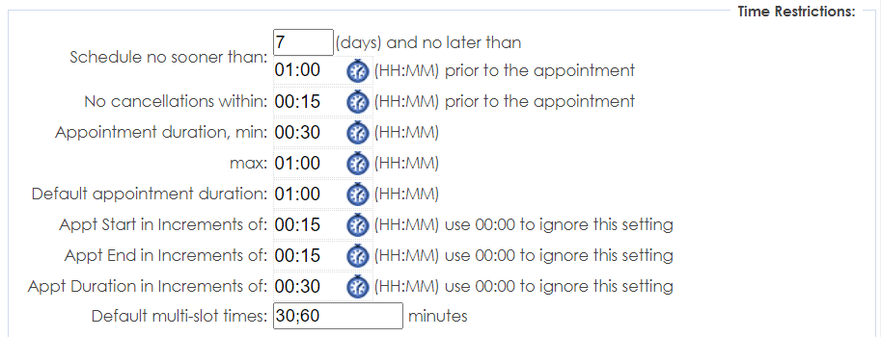
NB: If a student comes in physically to the center, for tutoring within an hour, they would be a drop in and no appointment would be made. Close attention to how close to the appointment can they be made or canceled to see if there are any issues.
Process for students to make appointments:
- Web browser, stutrac.eastcentral.edu
- Log in with username: first.lastname password: ECC password
- Click Search Availability
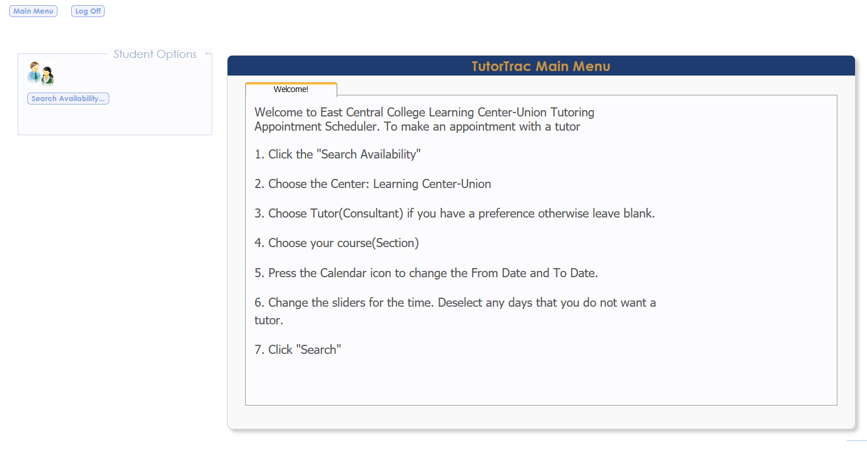
- Choose Center: Learning Center
- Choose Section: Class to receive tutoring
- Choose Date range (within 7 days), time, and days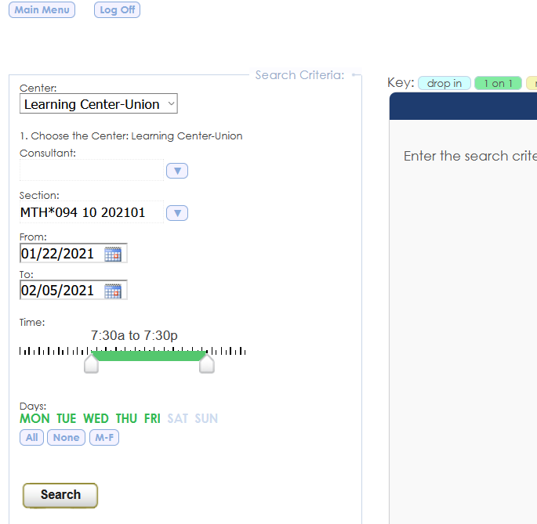
- Click Search

