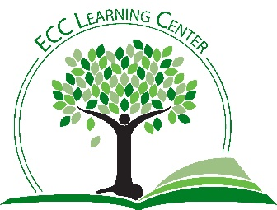
Getting Tech Ready
Although you can access your online courses on your phone through the Canvas mobile app, not all functions are available in the mobile app. Canvas is optimized for computers. If you need a computer, you can check them out at the ECC library. The ECC Library also has hotspots if you have “spotty” internet.
Required Technology
Phones:
- Android 6.0
- Apple iOS 13.0
Computers:
- PC: Windows 8.1 or newer
- MAC: OSX 10.6 or newer
Printer
NOTE: you can print in the ECC Learning Center or the Library. All ECC students receive $10 free printing per semester.
Headphones
If you do not have headphones, these can be checked out in the Learning Center for Center use.
Webcam
If you do not have a webcam, you can check one out in the Learning Center for center use.
Browsers
Follow instructor recommendations. This is critical.
Plug-ins
- Adobe Reader
- Java
EMAIL
- Locate ECC email and check daily
- If you use a personal email, be sure the address is appropriate and professional
- If you have difficulty logging into your email, stop by the Learning Center for help or contact the IT helpdesk: 636.584.6738

TOP 5 IT ISSUES/Solutions:
- Connections are loose. Check all cables and wires to be sure they are firmly in place.
- Surge protector switched off. Check red switch to be sure it is in the correct position.
- Battery low. Be sure to check battery on any portable device. Save work frequently.
- No sound: Sometimes, the programs have a separate volume control/mute.
- When all else fails: Restart your computer! You will be surprised how often this actually works.

HELP FOR CANVAS ISSUES
636.584.6609
onlinehelp@eastcentral.edu
TEXT: 636.388.8281

IT HELPDESK
636.584.6738

LEARNING CENTER
636.584.6688
General_tutoring@eastcentral.edu

