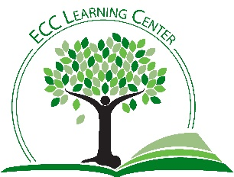
Online Learning Myths
MYTH #1: Online Classes are way easier!
FACTS:
- Online courses have the same workload as in-person courses
- More reading is required in online courses
- Assume you will need 9-15 hours per class, per week
MYTH #2: You can finish work early in an online class and be done for the semester.
FACTS:
- Course formats vary. Some teachers will open the entire course, but others will choose to open one week at a time.
- The expectations will be the same as in-person classes.
- You will get out of a course what you put into it. Don’t rush!
MYTH #3: I can hide in an online course.
FACTS:
- Interaction will still be required.
- Professors get reports showing the quantity and quality of your participation.
- You can still build meaningful relationships in an online course, but only if you participate.
MYTH #4: I spend a lot of time talking to friends on social media, and I text often. I don’t need to learn any technical skills to take an online course. Plus, my instructor will help me figure out any technical issues, right?
FACTS:
- Canvas, our Course Management System, is user-friendly. However, you will need to be sure you have a good grasp of the technology you will need.
- Do not attempt to take a class on your phone. While Canvas can be accessed on your phone to “check in,” not all functions are available in the online app. Canvas is optimized for computers.
- You can check out a computer at the East Central College library.
MYTH #5: Email is basically instant, and my teacher checks her email all of the time. So if I have a last-minute question or don't understand an assignment, I can just email her and she should respond right away. She's definitely up at 10 PM, and it only takes two minutes to respond with an answer.
FACTS:
- Instructors will provide a maximum email turnaround time, but 24-48 hours is typical.
- Plan ahead!
- Create alternate solutions, just in case your question is not answered in time.
  - Learning Center: 636.584.6688/general_tutoring@eastcentral.edu
  - Canvas Support: 636.234-3350/onlinehelp@eastcentral.edu/TEXT: 636.388-8281
  - Connect with other students. Consider forming a discussion group using GroupMe or some similar platform.
Myth #6: If I didn't finish my assignment on time, I can just say my computer crashed, or I deleted my file or I sent the wrong attachment.
- Your instructors have heard all of these excuses before!
- Be sure you fully understand the instructor’s expectations in advance.
- Create checklists or calendars to track assignments. NOTE: there is a calendar in Canvas that should show your assignments and due dates.

