**Slide 1 - Slide 1**

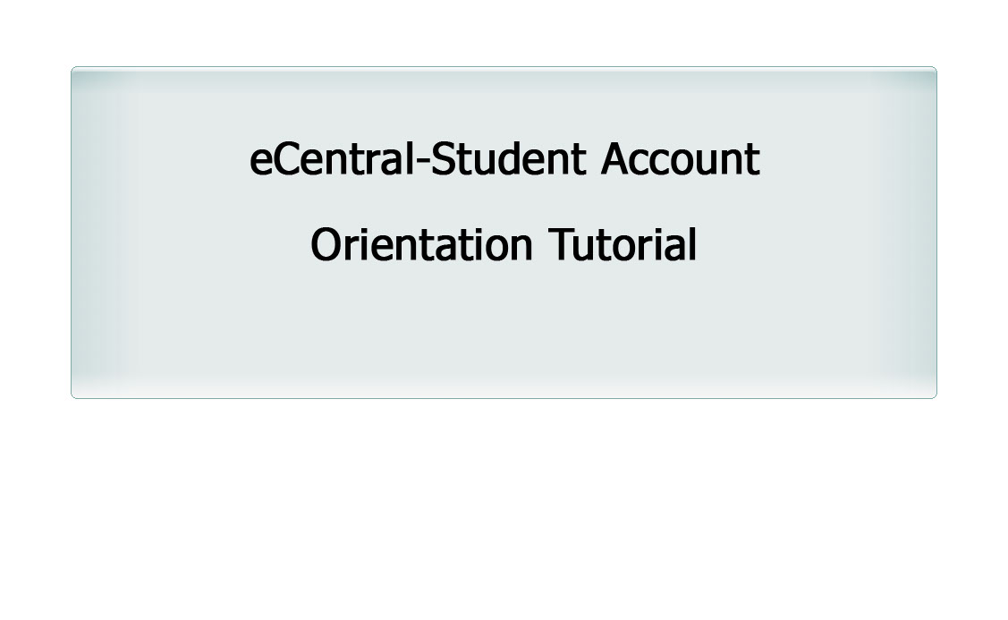

**Slide 2 - Slide 2**

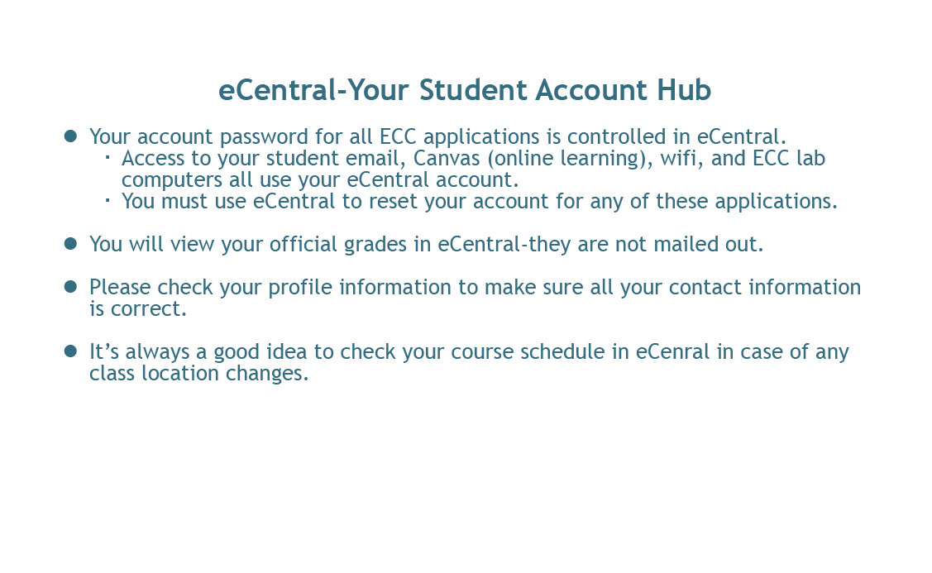

**Slide 3 - Slide 3**



**Slide 4 - Slide 4**

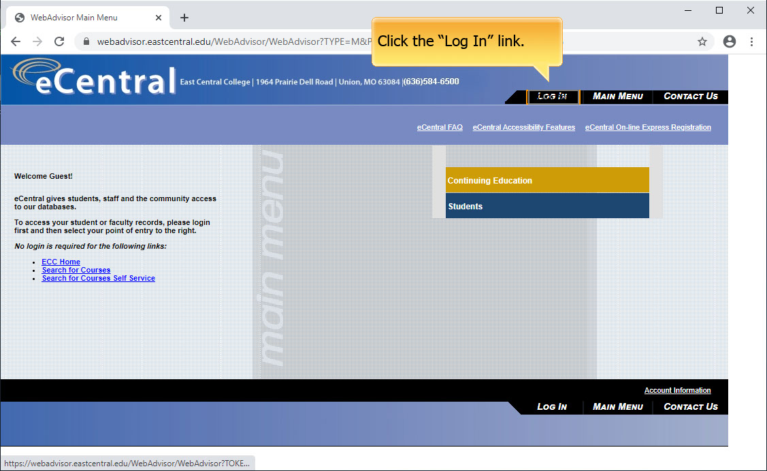

**Slide 5 - Slide 5**

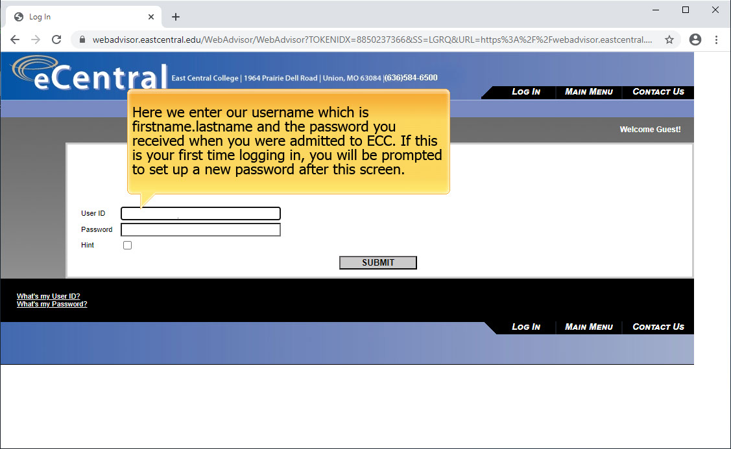

**Slide 6 - Slide 6**

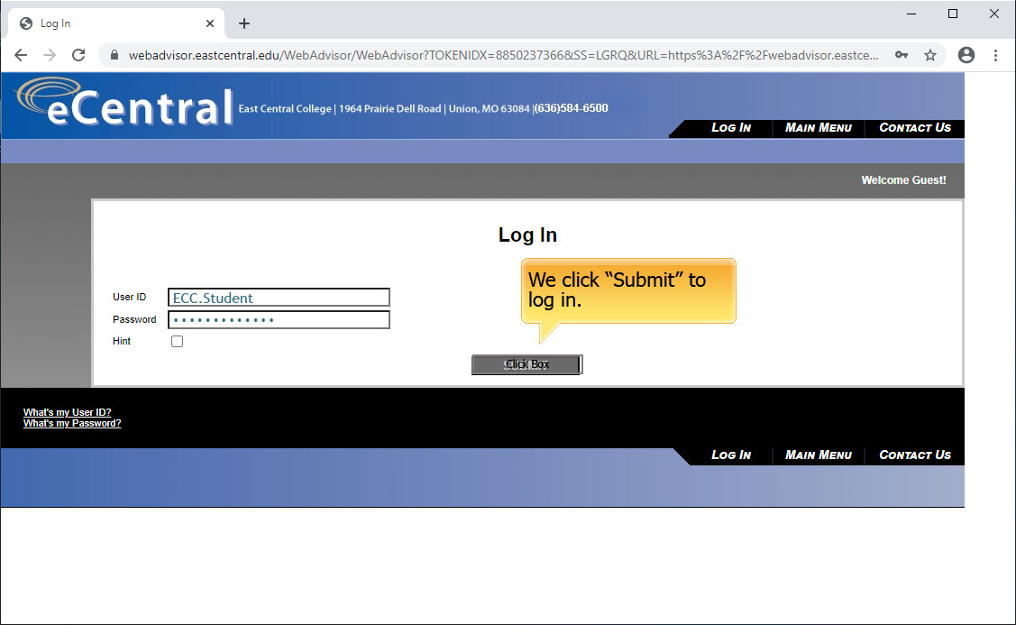

**Slide 7 - Slide 7**

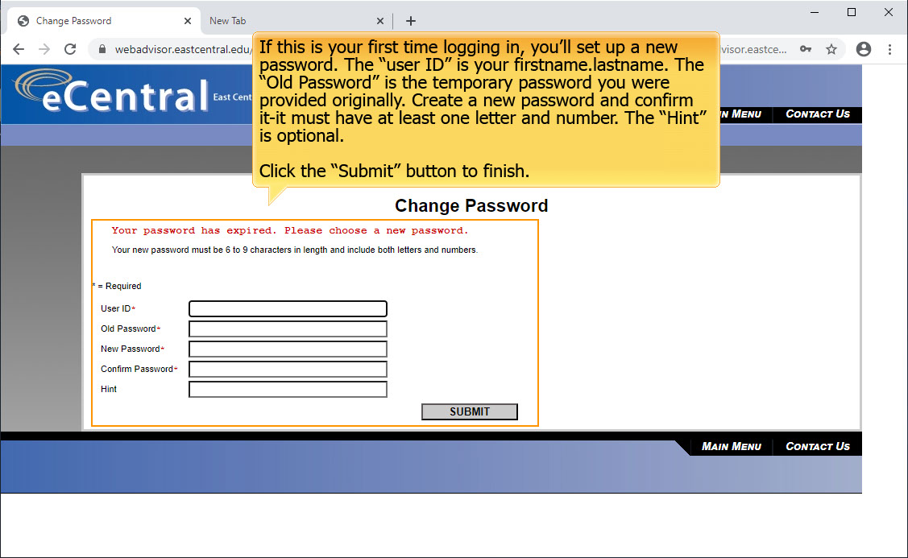

**Slide 8 - Slide 8**

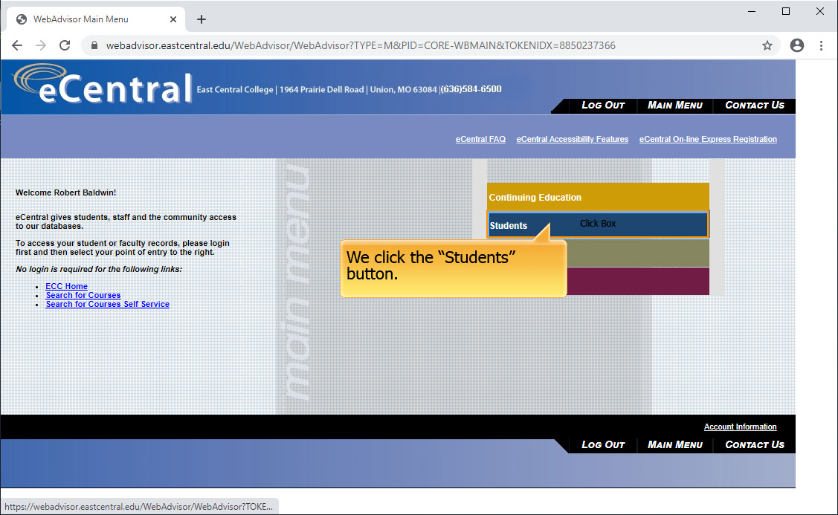

**Slide 9 - Slide 9**

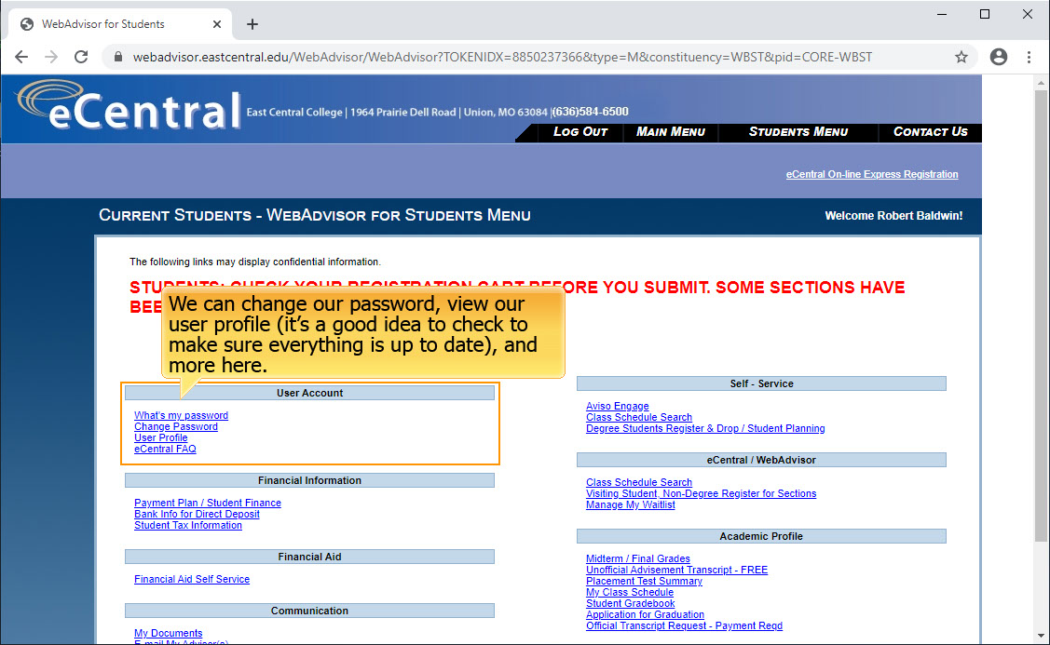

**Slide 10 - Slide 10**

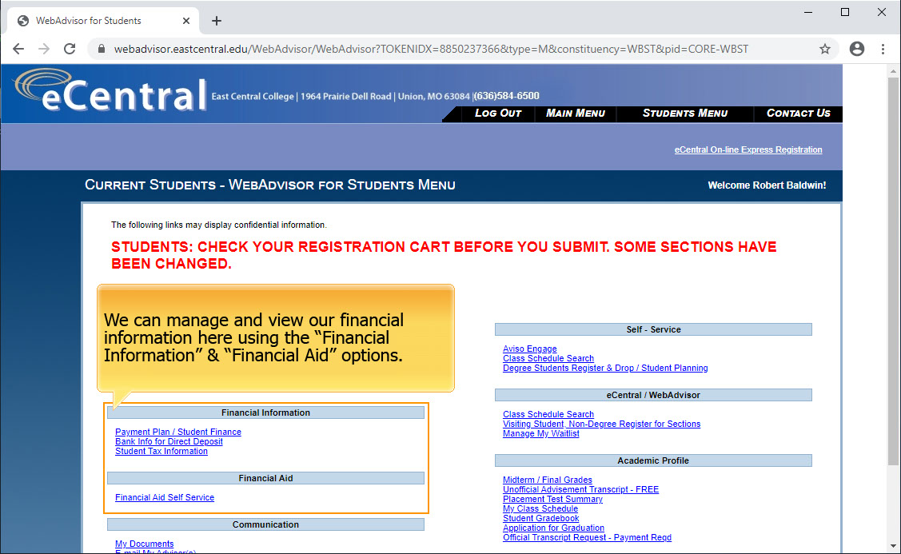

**Slide 11 - Slide 11**

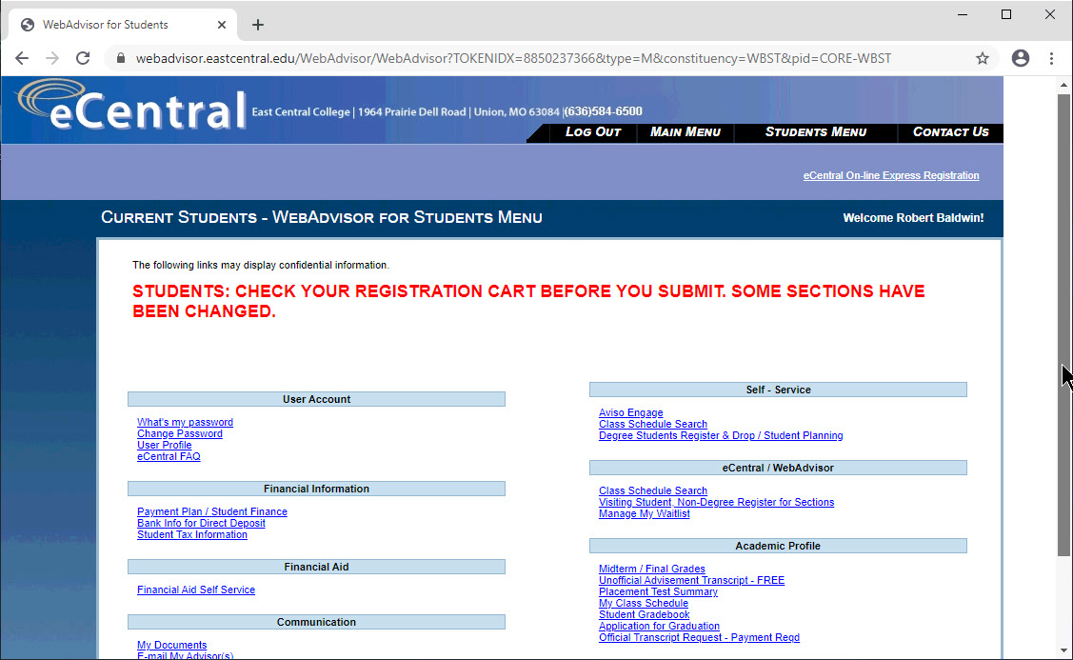

**Slide 12 - Slide 12**

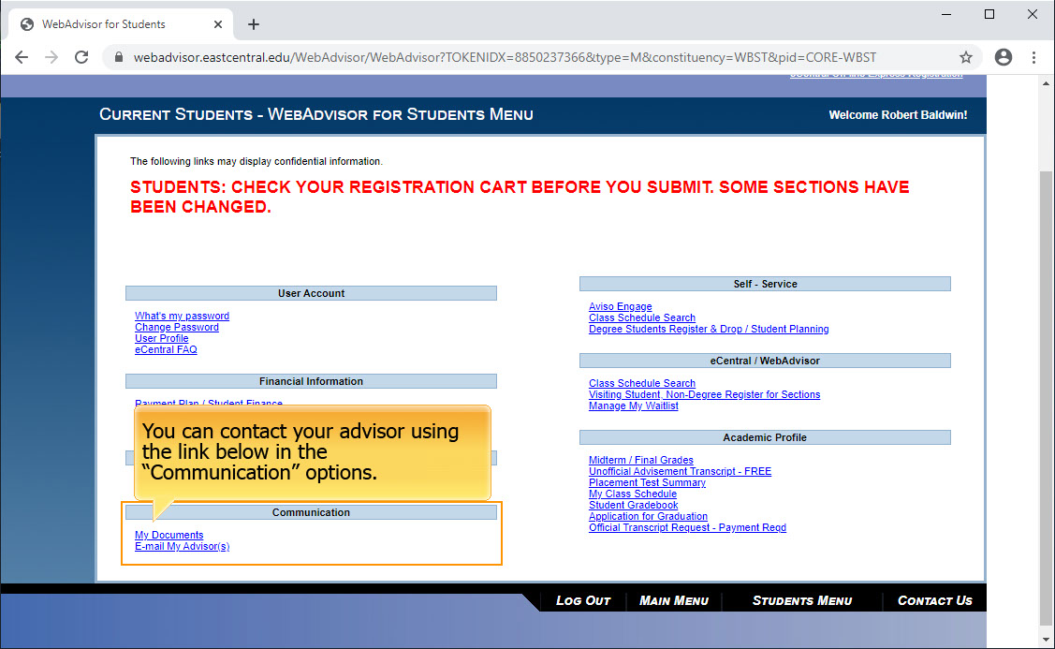

**Slide 13 - Slide 13**

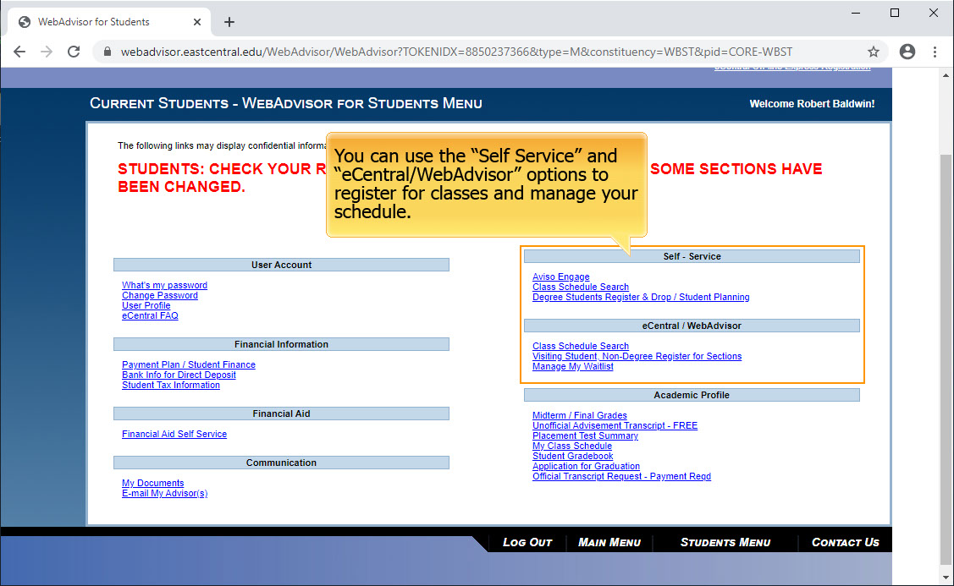

**Slide 14 - Slide 14**

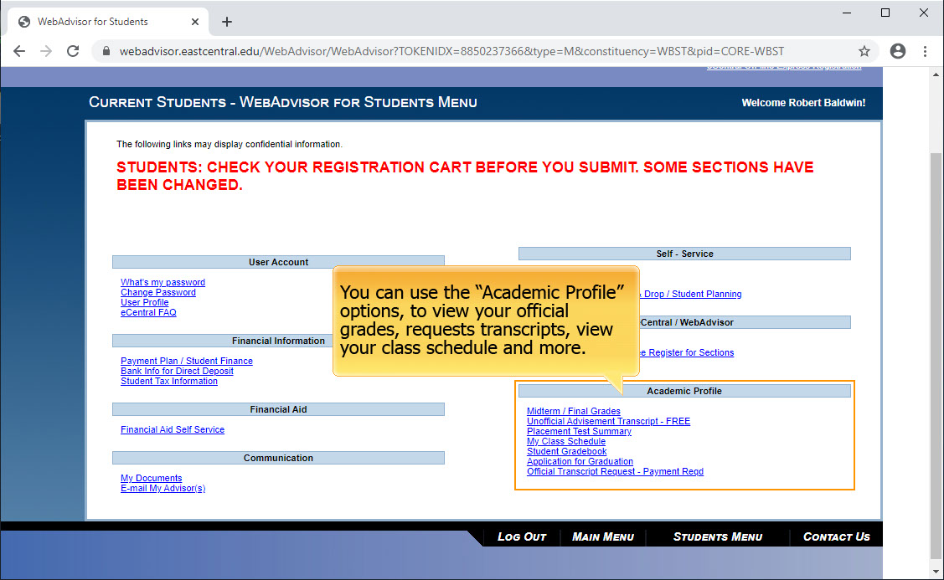

**Slide 15 - Slide 15**

