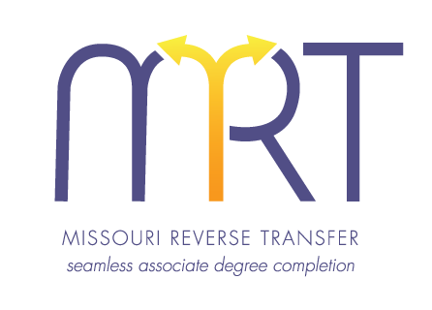
Opt-In/Graduation Application

In compliance with Missouri HB1042, Missouri colleges and universities are participating in the Missouri
Reverse Transfer statewide initiative which may enable you to earn an associate degree.

Name: _______________________________________________ Date of Birth: ____________________
(Please print your name as you wish it to appear on your diploma.)

Student ID# (4-year) ___________________________________ Last Four Digits of SS# _____________

Home Phone: _______________________________ Cell Phone: ________________________________

Mailing Address: _______________________________________________________________________
Street City State Zip Code

Primary e-mail: _____________________________ Secondary email: ___________________________

Current 4-year institution attending: ______________________________________________________

Previous institution(s) attended: _________________________________________________________

Associate degree you are seeking: ________________________________________________________

By completing this application, I authorize ____________________________ (current 4-year institution) to release my official transcript* to ______________________________ (previous 2-year institution). I agree to allow ______________________________ (previous 2-year institution) to review my academic records and post any degree for which I qualify. I understand that a final transcript* with my degree awarded will be provided to my current 4-year institution.

Student Signature: ___________________________________________ Date: _____________________

4-year RTC name: ________________________________ Signature: _____________________________

2-year RTC name: ________________________________ Signature: _____________________________

* I understand that the institutional transcript release policy applies.

