How to print a roster from Self-Service
- From the Home page, enter the Faculty section to view courses

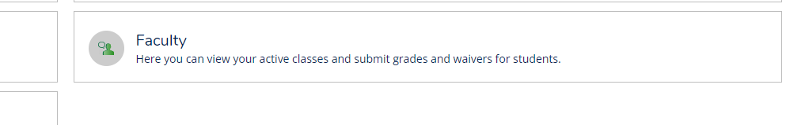
- Select course you wish to view
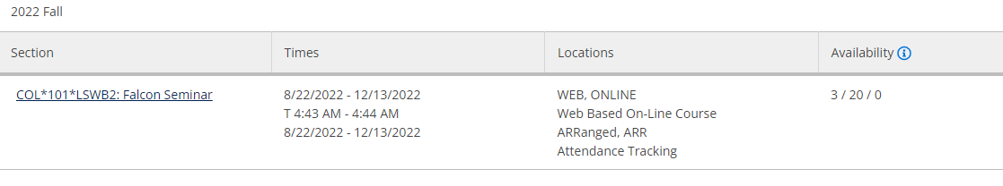
- From the Roster tab, select Export to Download CSV
