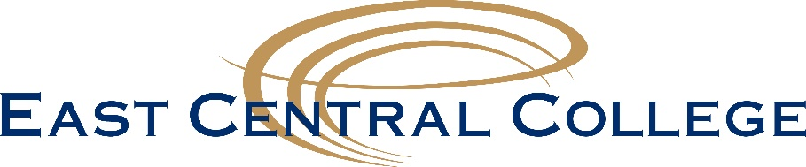

The following academic programs are eligible to receive FastTrack Incentive Grant funding through the Missouri Department of Higher Education.

* Accounting: Associate of Applied Science or Certificate of Achievement
* Automotive Technology: Associate of Applied Science or Certificate of Achievement
* Business: Associate of Applied Science or Certificate of Achievement
* Child Development: Associate of Applied Science or Certificate of Specialization
* Computer Information Systems: Certificate of Achievement
* Culinary Arts: Associate of Applied Science
* Heating and Air-Conditioning (HVAC): Associate of Applied Science or Certificate of Achievement
* Health Information Management (HIM): Associate of Applied Science or Certificate of Achievement
* Industrial Engineering Technology: Associate of Applied Science, Certificate of Achievement or Certificate of Specialization
* Medical Assistant (MDA): Associate of Applied Science or Certificate of Achievement
* Nursing: Associate of Applied Science
* Nursing Bridge (LPN to RN): Associate of Applied Science
* Occupational Therapy (OTA): Associate of Applied Science
* Paramedic Technology: Associate of Applied Science or Certificate of Achievement
* Precision Machining: Associate of Applied Science, Certificate of Achievement or Certificate of Specialization
* Pre-Engineering: Associate of Arts or Associate of Science
* Radiologic Technology: Associate of Applied Science
* Welding: Associate of Applied Science, Certificate of Specialization or Certificate of Achievement