[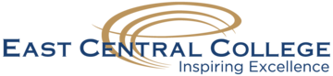](http://www.eastcentral.edu/)

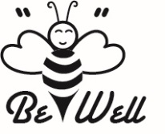

“Be Well” Passport Enrollment Form

The **“Be Well” Passport** is a semester long incentive which allows full-time employees to earn points towards Gold, Silver and Bronze Achievement Award Levels by participating in a variety of the health and wellness related activities. When you attend an event or complete a challenge, simply have a committee member stamp your passport.

The initial **“Be Well” Passport** will run from April 19, 2016 – December 9, 2016.  At the end of the semester, turn in your passport to HR by the deadline and we will announce the winners/results at Back to School week in January 2017.

Professional Staff and Support Staff will earn paid time to work out (walk, run, fitness center) at work so that you can be more active! Full-time faculty will earn gift cards due to the current flexibility in their schedules.

**Employee Information:**

Name: EE ID:

Department: ______ Building/Office #:

**Acknowledgement of Participation:**

**Risks** – By participating, you understand there is a certain amount of risk of injury when completing certain activities. Please consult with your doctor prior to participating if you have concerns about health risks.

**Reasonable Alternatives** – If it is reasonably difficult due to a health factor for you to meet the requirements under this program, we will make available a reasonable alternative standard for you. Please see Human Resources for more information.

**Integrity** – By participating in this program you agree to be honest and truthful regarding your participation.

______________________________ ______________________

Signature Date