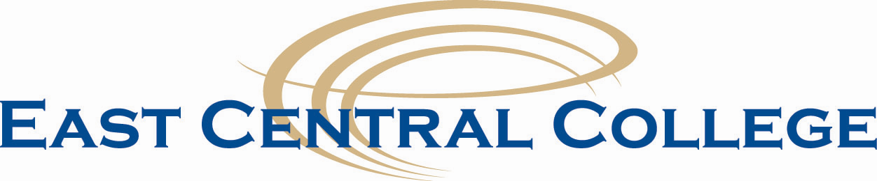

Human Resources Interoffice Memo

2020 Holiday Schedule

The College will be closed on the following days in accordance with the Board Policy:

New Year’s Day Wednesday, January 1

Martin Luther King, Jr. Day Monday, January 20

Good Friday Friday, April 10

Floating Holiday Friday, May 22

Memorial Day Monday, May 25

Independence Day observed Friday, July 3

Labor Day Monday, September 7

Thanksgiving Break Wednesday, November 25 - Friday, November 27

Christmas Break Monday, December 21 – Thursday, December 31

Approved 2-27-18

