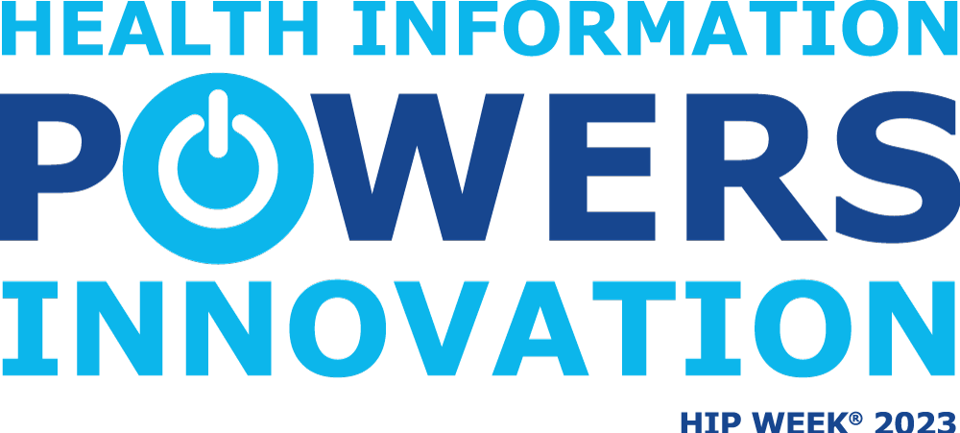

**Health Information Professional Week**

**April 17-23, 2023**

**To learn more about the**

**ONLINE**

**Health Information Management Program at ECC**

**email** [**kim.daman-scheel@eastcentral.edu**](mailto:kim.daman-scheel@eastcentral.edu)**,**

**or call 636-584-6662, or**

**stop by the HIM office in HH 306B**