**Page 1 information**

can use either on the following logos:

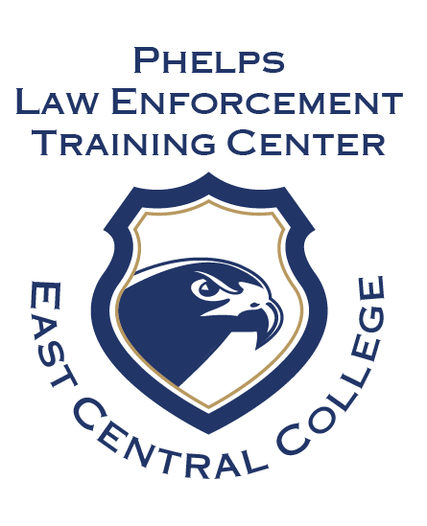 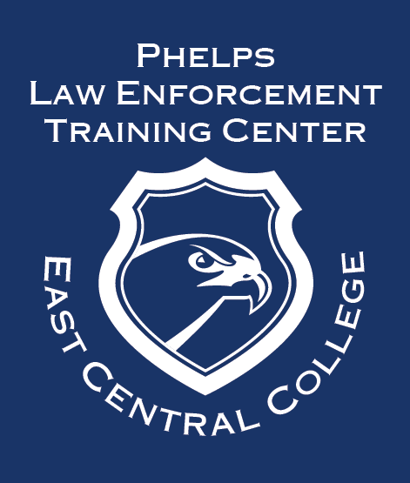

The Law Enforcement program is offered at the East Central College Rolla North site located at 2303 North Bishop. The 1-year certificate program combines theory, experiential learning, and practical applications to prepare students for a career as a peace officer.

The purpose of the law enforcement program is designed to assist students to acquire the skills and knowledge essential to the role for a competent peace officer. Students who successfully complete this Peace Officer Standards and Training (POST) approved program receive a certificate of achievement and are eligible to take the Missouri Peace Officer License Exam (MPOLE) to become a licensed peace officer.

Students may choose to pursue the Associate of Applied Science in Law Enforcement by completing additional general education courses on a full- or part-time basis prior to entering or after the completion of the law enforcement certificate program.

Applications Due: June 1, 2023

Class begins: August 21, 2023 and ends July 27, 2024

For more information visit: [www.eastcentral.edu/LETC](http://www.eastcentral.edu/LETC), 573-202-6960, LETC@eastcentral.edu

A selective admission process is utilized for this program:

* Create QR code for application link: [Application for Certificate in Law Enforcement Basic Training Program](https://www.eastcentral.edu/social-sciences/wp-content/uploads/sites/11/2023/03/Application-Certificate-Law-Enforcement-2023.pdf)

Admission Requirements:

* For consideration, applicants must meet the following minimum criteria:  
  20+ years of age prior to the start date of the 1-year law enforcement certificate coursework

*\*NOTE: If the applicant has provided written verification of current employment as a non-  
commissioned employee of a law enforcement agency, is otherwise eligible to apply for a peace  
officer license pursuant to 11 CSR 75-13.020, and will turn twenty (20) years of age prior to taking the MPOLE at the end of program, the applicant may apply for the program*

* U.S. citizen with a current, valid driver’s license
* High school diploma or the equivalent
* Application for admission to ECC
* Placement into or successful completion of English Comp I
* Vision in each eye must be correctable to 20/40.
* “Honorable” or “under honorable conditions” discharge (if served in the military)
* Completion of initial physical fitness assessment and applicant interview
* A completed law enforcement basic training application on file by the specified deadline (available at www.eastcentral.edu/LETC)
* Complete the
* Satisfactory criminal background check, drug screening, and physical once accepted to the program.

**Page 2 information**

Law Enforcement Course information from Pathway Document (Year 1 – Certificate + Year 2 to complete the AAS degree)